Product Development Service Document

By



**For EF Software Product: eTMS**

Contents

I. General Information 4

1. Interface 4

2. Framework 4

3. URL 4

4. Timeline 4

I. System Structure 5

1. General Structure 5

II. Wireframes 6

1. Dashboard 6

2. Global Config 9

2.1 Attendance 9

2.2 Public Holiday 11

3. Company 14

3.1 Company Details 15

3.1.1 Basic Information 15

3.1.2 Division 16

3.1.3 Site 18

3.1.4 Job Site 20

3.2 Company Config 20

3.2.1 Attendance 20

3.2.2 Resign Reason 24

3.2.3 Public Holiday 26

3.2.4 Race 28

3.2.5 OT Code 30

3.2.6 Allowance 32

3.2.7 Shift 34

4. Job Site 36

4.1 Job Site List 36

4.1.1 Job Site Basic Information 37

4.1.2 Job Site – Zone Location 38

4.1.2.1 Job Site – Level 40

4.1.2.2 Job Site – Area 42

4.1.2.3 Job Site – Location 44

4.1.2.4 Job Site – Zone 46

4.1.2 Job Site Employee 48

4.2 Job Site Config 48

4.2.1 Job Site OT Setting 48

4.2.2 Job Site Allowance 50

4.2.4 Job Site Shift 52

5. Employee 54

5.1 Employee Details 55

5.2 Employee Event – Promotion 57

5.3 Employee Event – Termination/Resign 59

5.4 Employee Rejoin 60

5.5 Employee Contract 62

5.6 Employee Transfer 64

5.7 Employee Roster 66

# General Information

## Interface

Frontend

Admin

## Framework

Frontend: Angular JS 5

Admin panel: .NET Core 2.1

Database: Microsoft SQL 2016

## URL

Documents are pending.

## Timeline

To be updated after the confirmation of this document.

# System Structure

## General Structure

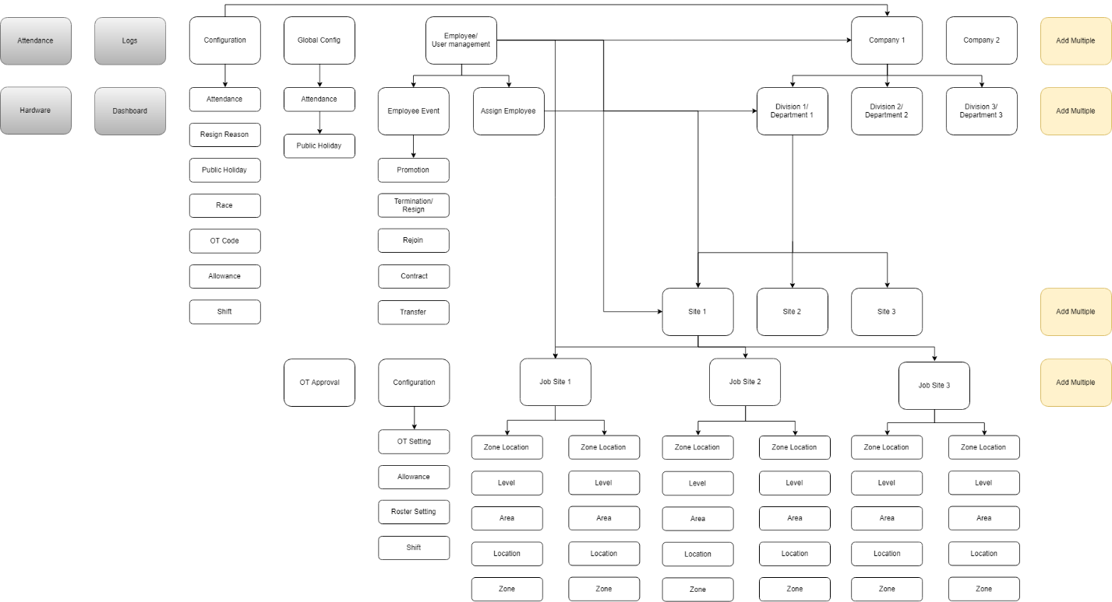

Figure 1: General Structure

# Wireframes

## Dashboard

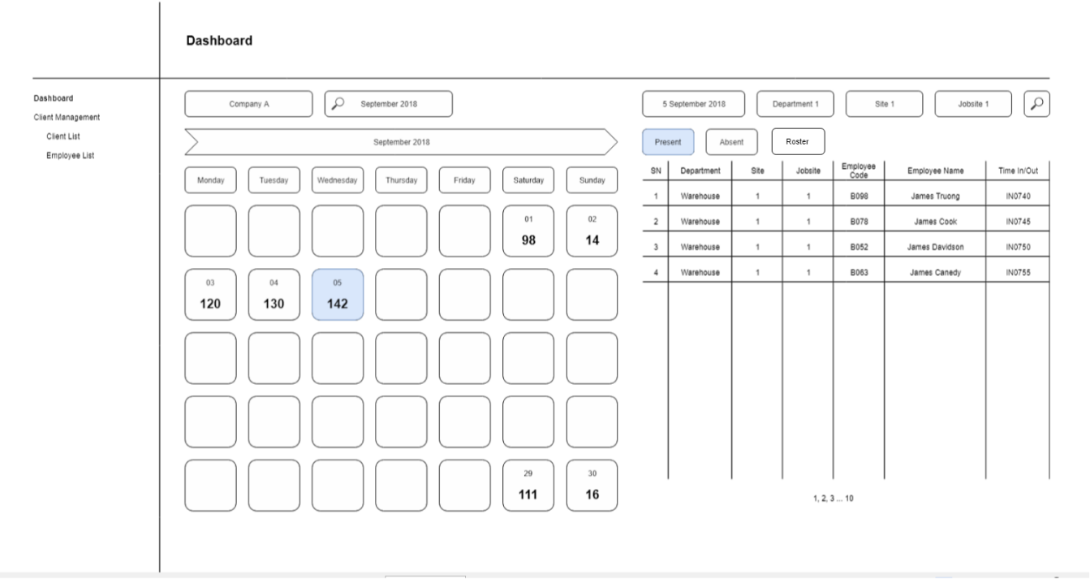

Figure 2: Dashboard

Notes:

* Time IN and Time OUT are two difference columns.
* Click on “Roster” to show Employee Roster List (page 8).
* Can click on Name of an Employee on a day to show pop up details below: page 7.

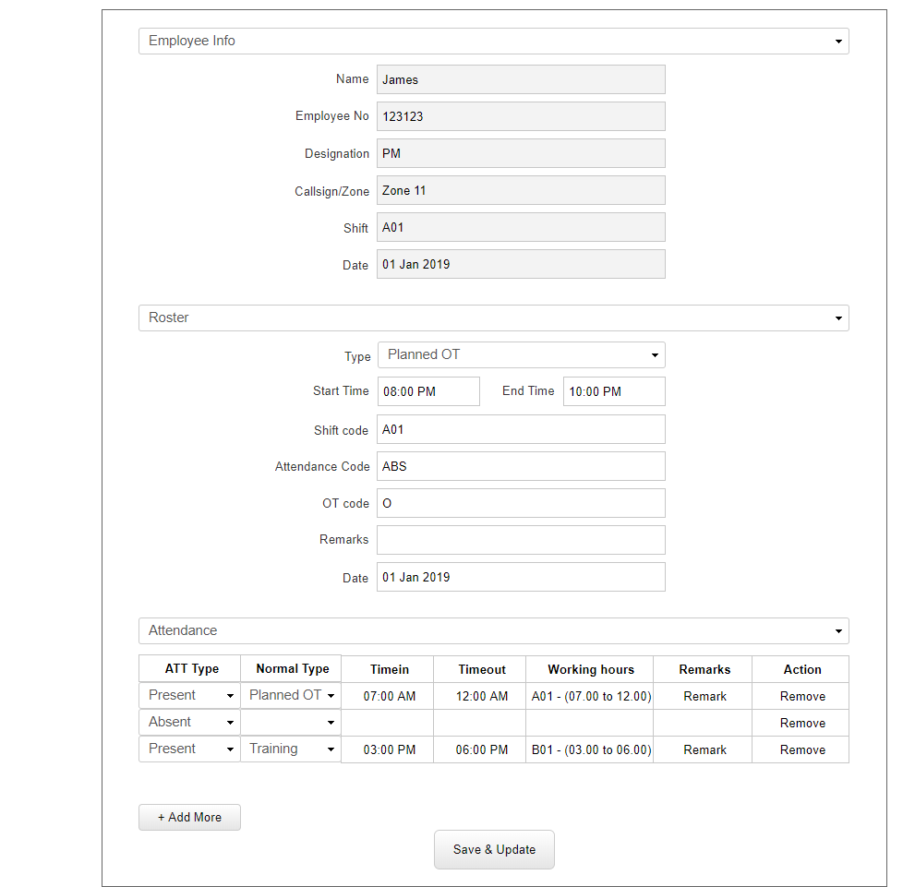

Figure 3: Manual Recording

Notes:

* Only show Employee Info from Employee Details, cannot edit them.
* Admin can update info of the roster code.
* Can add an or many attendance code for an Employee.
* Working hour (Shift) can be automatically retrieved from Job Site Shift.
* ATT Type includes: Present and Absent.
* Normal Type includes: Planned OT, Vaccination, Training.
* Can click on “Remove” to delete an attendance code.

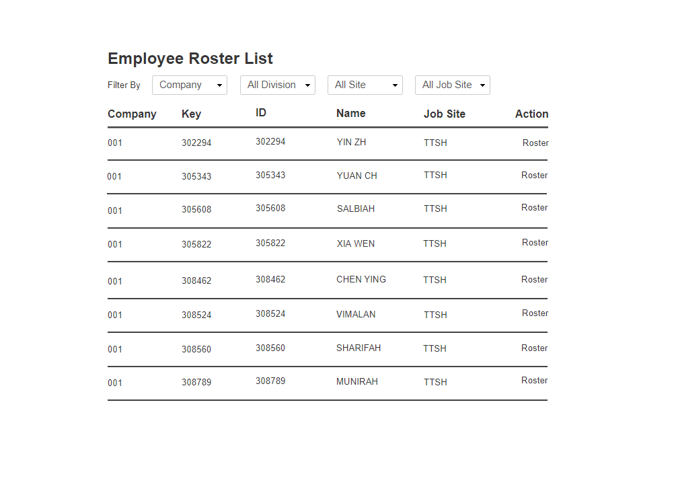

Figure 4: Employee Roster List

## Global Config

### Attendance

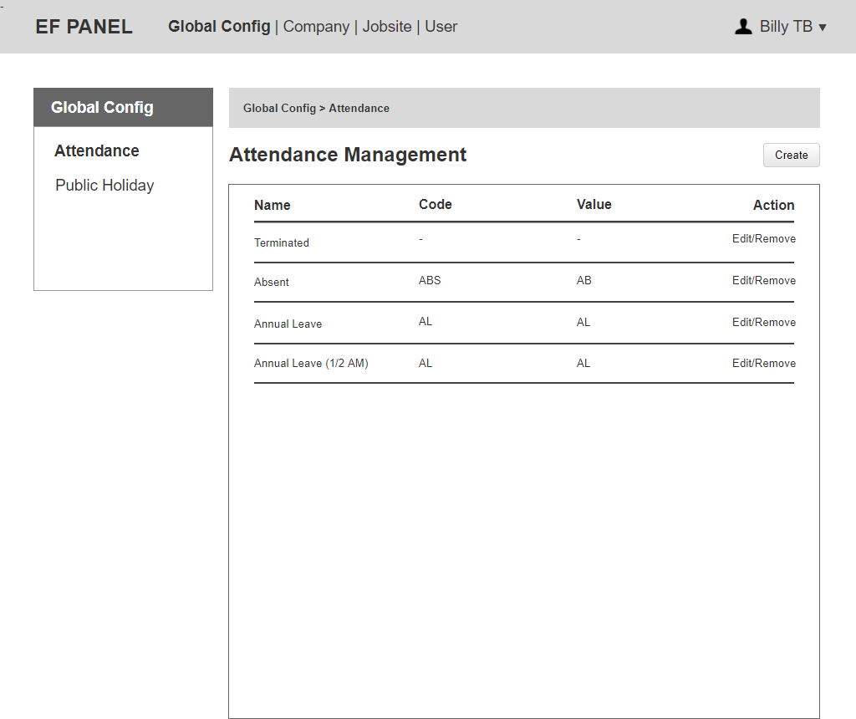

Figure 5: Attendance List

Notes:

* After creation, an attendance can only be removed if it has not been used (no children).
* EF Admin can click on “Edit” to update Name, Code, Value of an attendance.
* EF Admin can click on “Create” to add a new attendance.

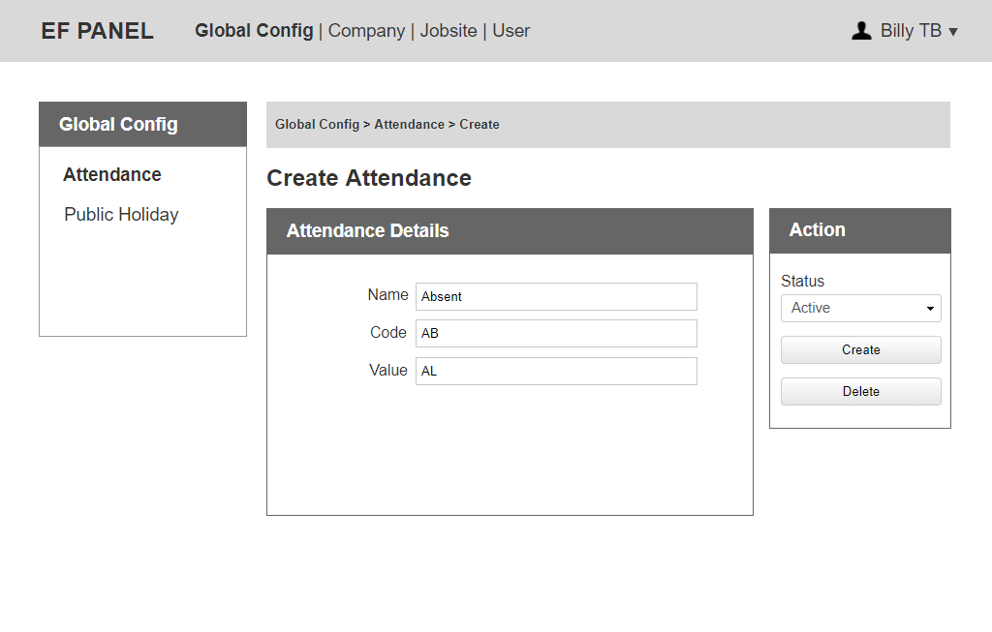

Figure 6: Create Attendance

Notes:

* Global EF Admin can edit all information of an attendance.
* The status includes: Active, Inactive.
* EF Admin can change the status to Active/ Inactive.

### Public Holiday

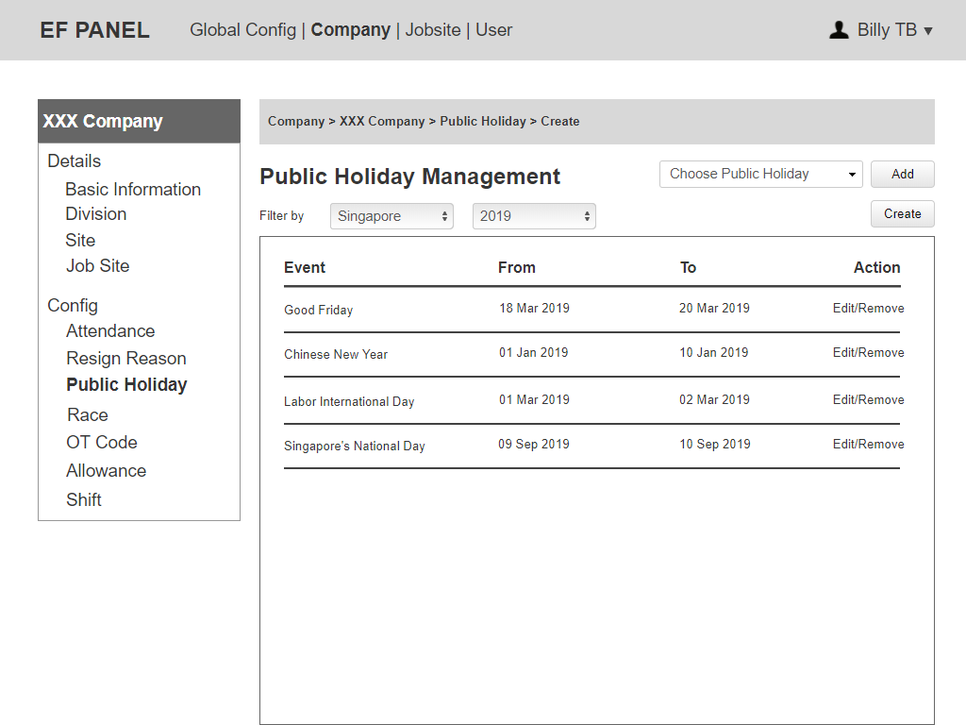

Figure 7: Public Holiday List

Notes:

* After creation, a public holiday can only be removed, if it has not been used (no children).
* EF Admin can click on “Edit” to update Event, Start Date, End Date, Year, Country of Public Holiday.
* EF Admin can click on “Create” to add a new public holiday in the same category chosen.
* The default country and year on "Create Public Holiday Page" is the one filtered on "Public Holiday List Page".
  + E.g If EF admin filter "Singapore - 2019" on Public Holiday List Page, when Admin click on "Create", the country & year choose "Singapore - 2019" by default on "Create Public Holiday Page".

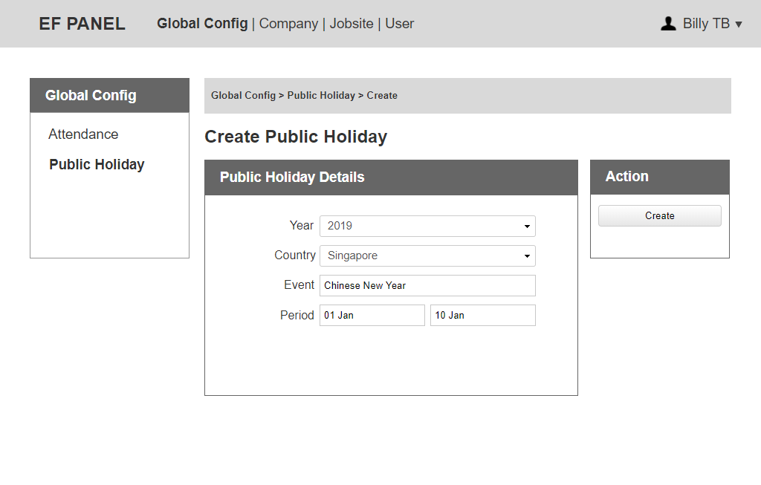

Figure 8: Create Public Holiday

Notes:

* Country and Year are dropdown, Global EF Admin must choose value for them before creating a new public holiday.
* Can create a public holiday in the future.
* Cannot create a public holiday, which has the same year/country/period with the listed public holiday.

## Company

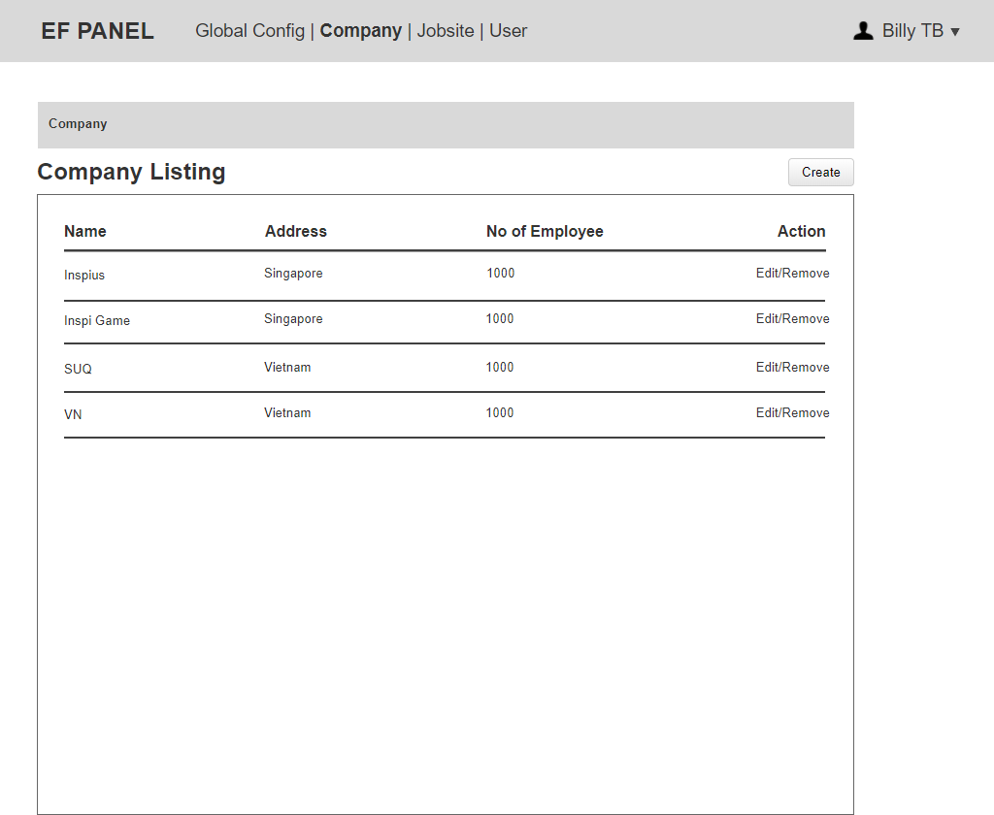

Figure 9: Company Listing

Notes:

* Only EF Admin is able to see “Company Listing Page”. Company admin cannot see “Company Listing Page”, they can only have access from the “Company - Basic Information”.
* EF Admin can click on “Edit” to update all information of company details.
* EF Admin can remove a company if there is no transaction.
* (1st approach) 1 company might have its own database or (2nd approach) multiple companies can share 1 general data. At the 1st phrase, we only do 2nd approach.
* Number of Employee is automatically generate from the list of active employee belongs to this company.

### Company Details

### 3.1.1 Basic Information

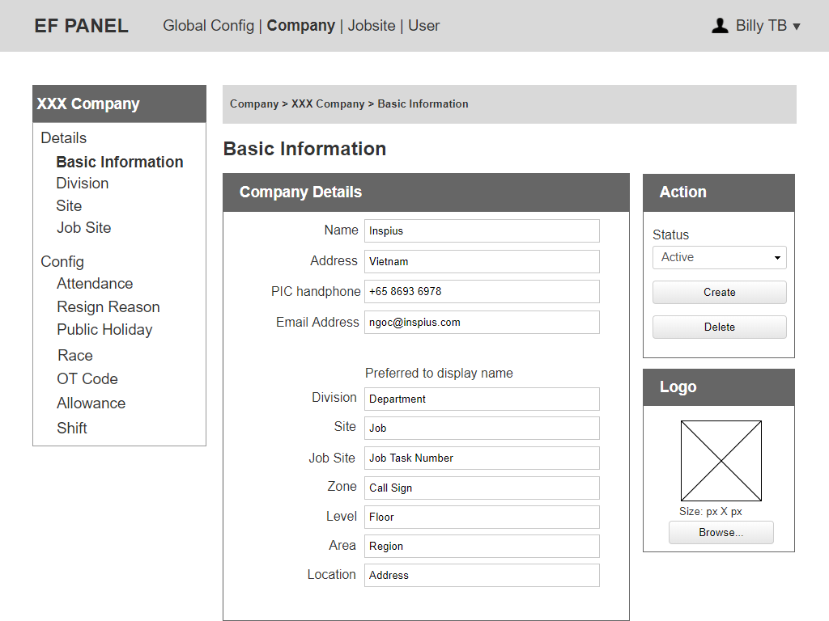

Figure 10: Basic Information

Notes:

* Company Admin can update a preferred display name (of Division, Site, Job Site, Zone, Level, Area, Location) for left side menu and any related place as header, title, breadcrumb.
* If Preferred-to-display name is updated, the menu would be updated follow it. If the preferred-to-display name is blank, the menu would be the default menu.
* Preferred name fields are free text boxes.

### 3.1.2 Division

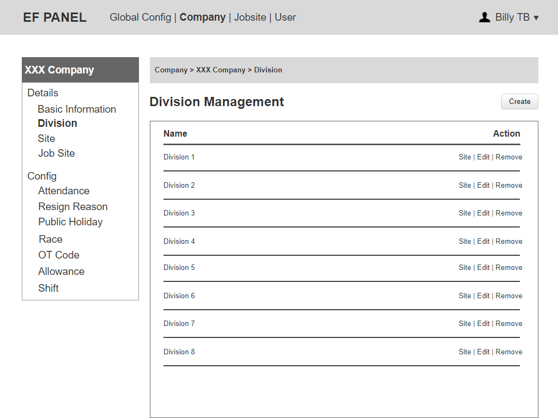

Figure 11: Division List

Notes:

* EF Admin and Company Admin can click on “Site” to show list of the site belongs to the division.
* EF Admin and Company Admin can click on “Edit” to update name of the division.
* EF Admin and Company Admin can remove a division if there is no children yet.

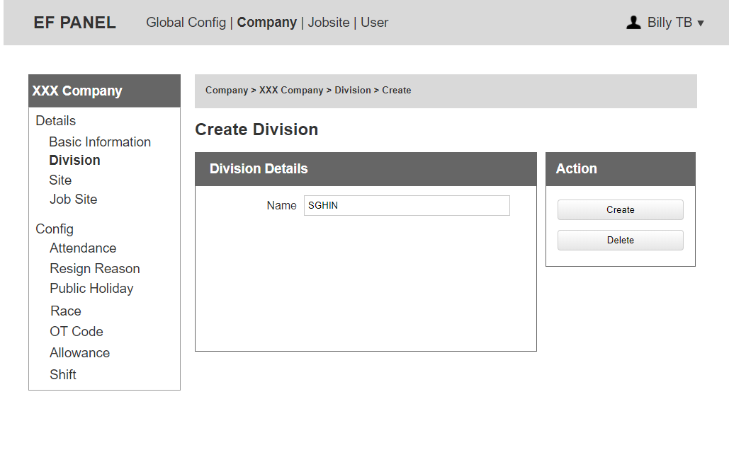

Figure 12: Create Division

Notes:

* Able to delete if there is no children yet.

### 3.1.3 Site

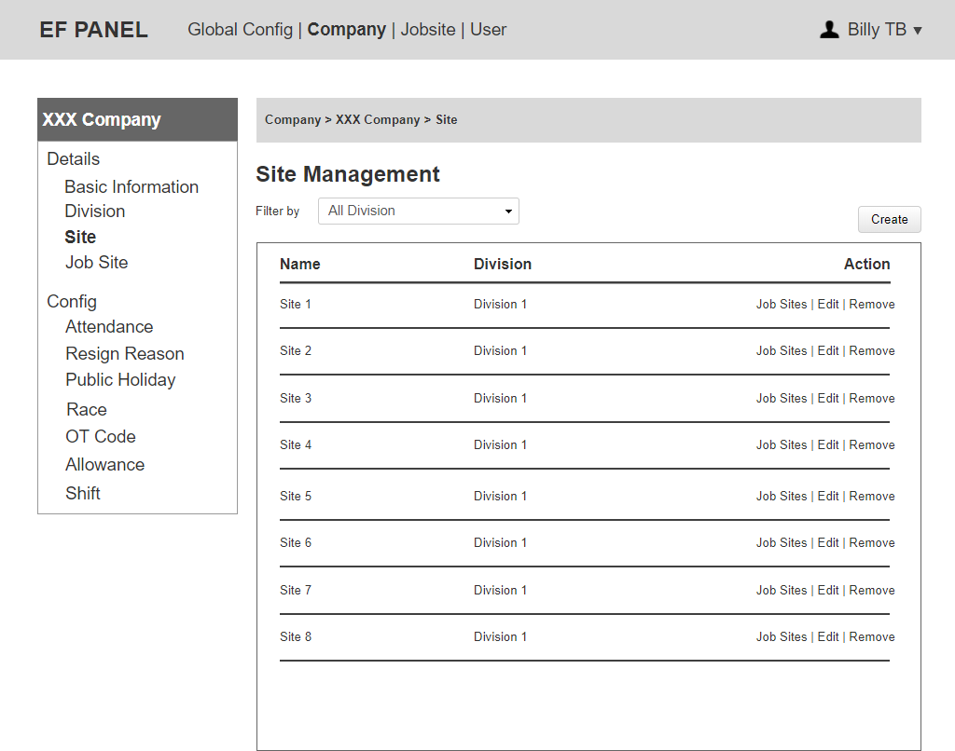

Figure 13: Site List

Notes:

* EF Admin and Company Admin can click on “Edit” to update name and division, which this site belongs to.
* Disable to remove any Site if there is no children yet.
* EF Admin and Company Admin can click on “Job Site” to see list of job site for this site.

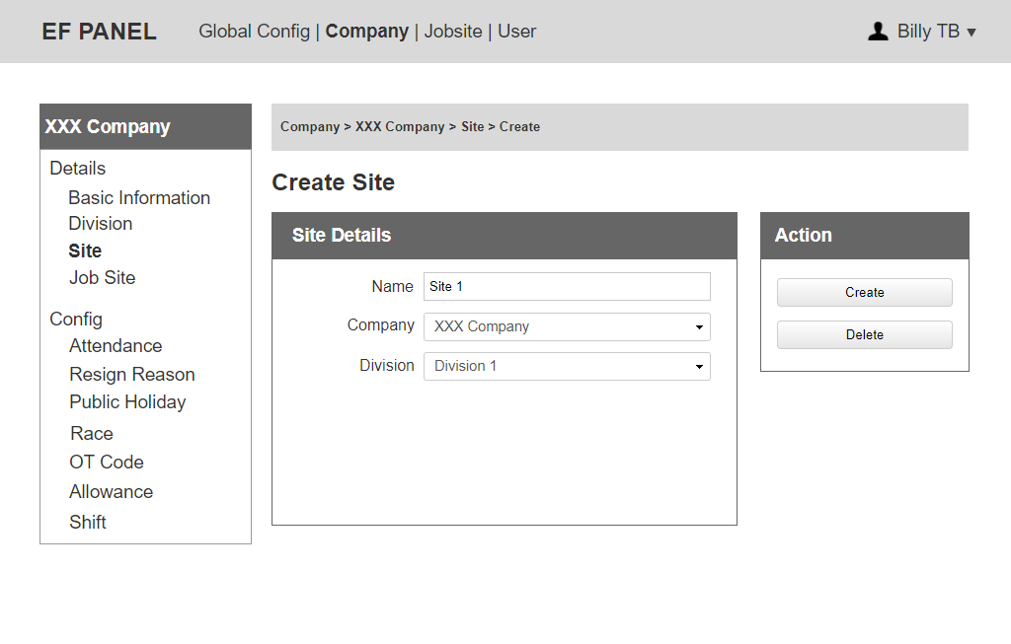

Figure 14: Create Site

Notes:

* Company Admin can edit name, choose Division.
* Only EF Admin can edit Company dropdown, Company Admin cannot.
* Able to delete if there is no children yet.

### 3.1.4 Job Site

It will be shown in point 5 on the below page.

### Company Config

Notes:

* EF Admin and Company Admin can edit information for Company Config.

### 3.2.1 Attendance

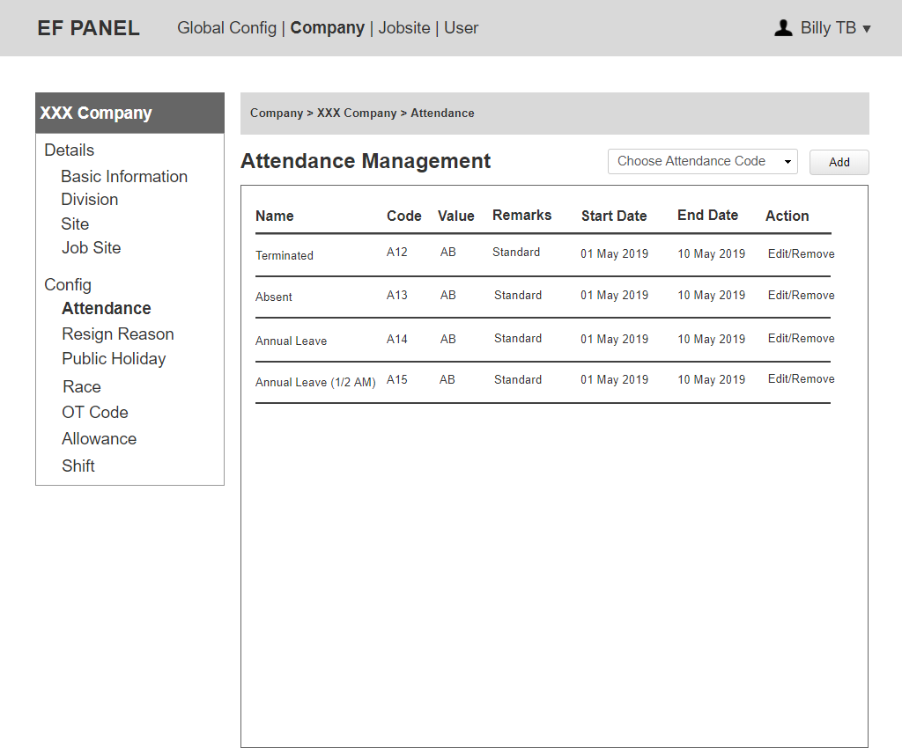

Figure 15: Attendance List

Notes:

* The system will list all active attendance code in Global Config to dropdown "Choose Attendance Code”.
* Company Admin can click on “Remove” to stop using an attendance code and it will be delete from Current Attendance List of this company.
* Code and Name must be unique but value can be the same. If a name and a code are being used, they cannot be shown in dropdown to choose again.
* An attendance code can only be added back to the “Choose Attendance Code” dropdown if the old one is Expired/Inactive.
* Step for Company Admin to add the attendance code then config it:
  + Choose attendance code (generate active attendance code from global configuration) then click “Add".
  + The system adds a new attendance code to the list (the start date, end date, remarks are blank).
  + EF Admin/Company Admin can edit to add start date, end date and remarks. If Admin do not edit these value, they will use default value belongs to Global Config.

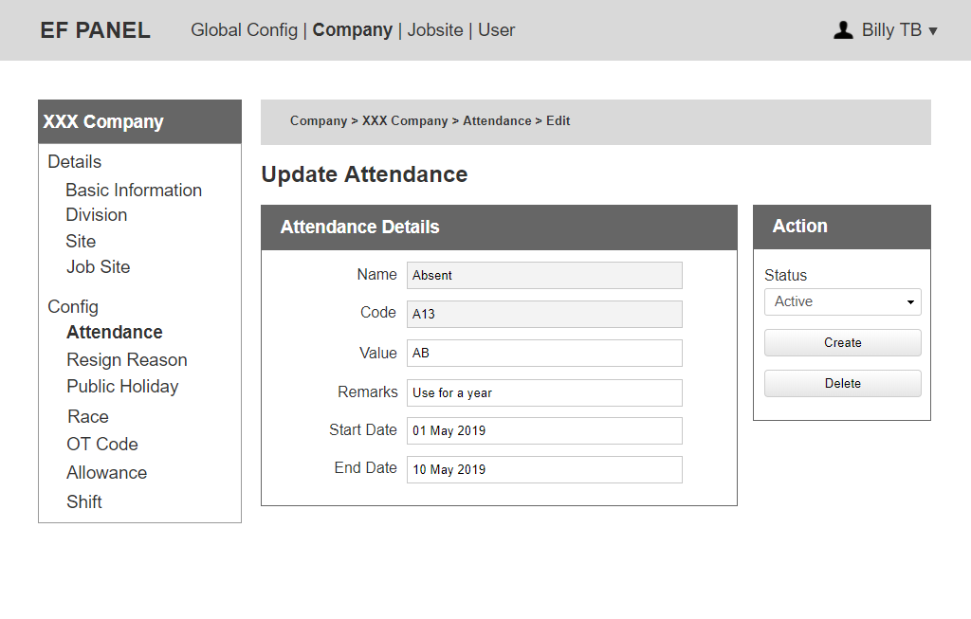

Figure 16: Update Attendance

Notes:

* Company Admin cannot edit name, code. They only can add, edit values in these fields: remarks, start date, end date, value.
* Company Admin can click on “Delete” to stop using an attendance code and it will be remove from Current Attendance List of this company. Able to remove if there is no children yet.
* Unable to edit value, remarks, start date, end date if the hardware recorded the attendance code.
* When an attendance is expired, the dropdown of status is hidden and replaced by Expired**.** The system notices Company Admin this attendance code is expired. Do you need a place to store all notification for admin?
* Company Admin can change the status to Active/Inactive.
* End date is blank so that attendance code is infinitive.
* For an expired attendance code, all information of that can still save in database management system to export.

### 3.2.2 Resign Reason

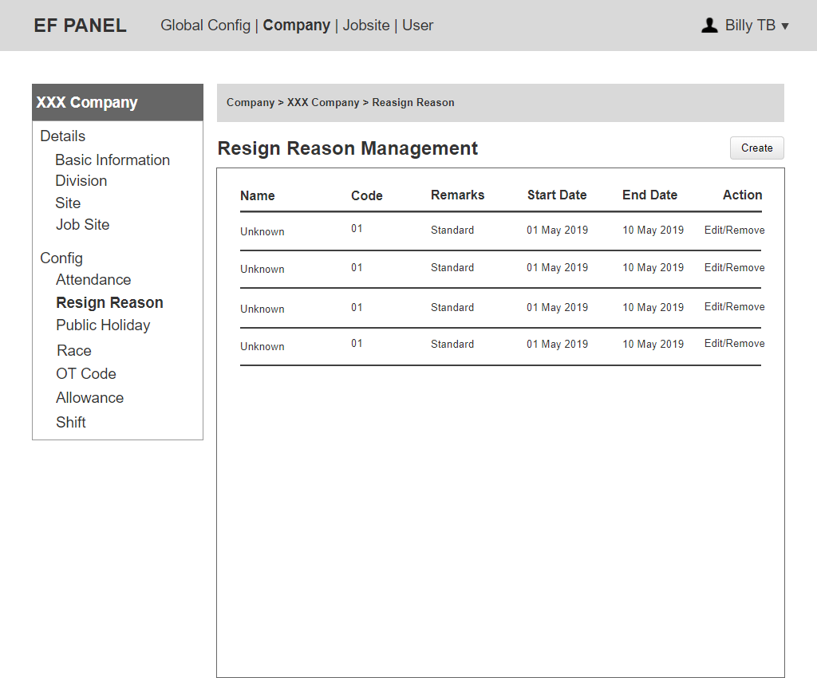

Figure 17: Resign Reason List

Notes:

* Company Admin can edit all information of a resign reason.
* Company Admin can click on “Create” to add a new resign reason.
* Company Admin can click on “Remove” to delete a resign reason.

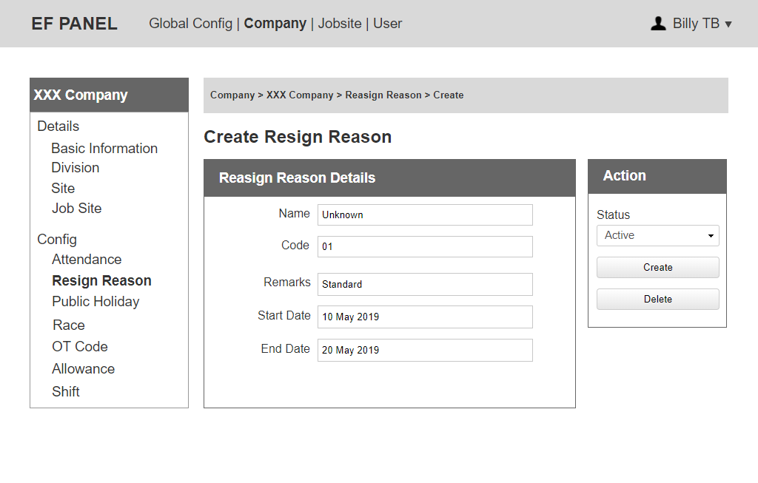

Figure 18: Create Resign Reason

Notes:

* The status includes: Active, Inactive.
* When a resign reason is expired, the dropdown of status is hidden and replaced by Expired**.** The system notices Company Admin this resign reason is expired. So it cannot be used if Company Admin does not change End Date as valid.
* Company Admin can change the status to Active/ Inactive.
* Able to remove if there no children yet.

### 3.2.3 Public Holiday



Figure 19: Public Holiday List

Notes:

* EF Admin and Company Admin can click on “Edit” to update Country, Year, Start Date, End Date of a public holiday.
* The system will list all active public holiday code in Global Config to dropdown "Choose Public Holiday”. And if a name and a code are being used, they cannot be shown in dropdown to choose again.
* A public holiday can only be added back to “Choose Public Holiday” dropdown if the old one is Expired/Inactive.
* Company Admin can click on “Remove” to stop using a public holiday code then it will be delete from Current Pubic Holiday List of this company. And able to remove if there is no children yet.

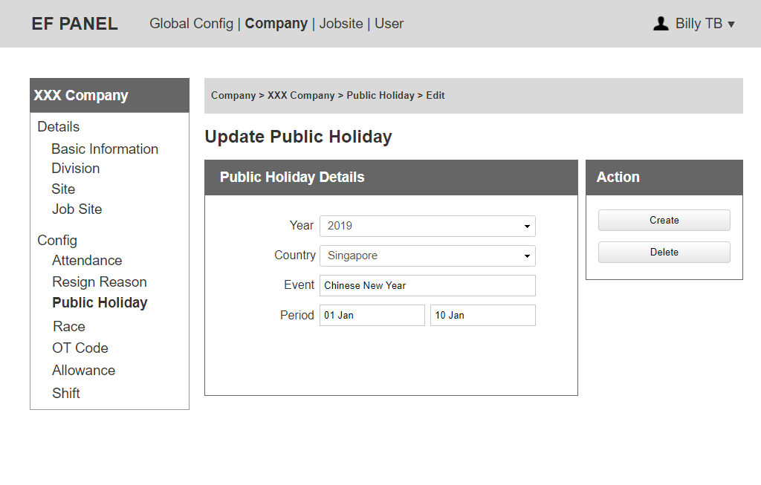

Figure 20: Update Public Holiday

3.2.4 Race

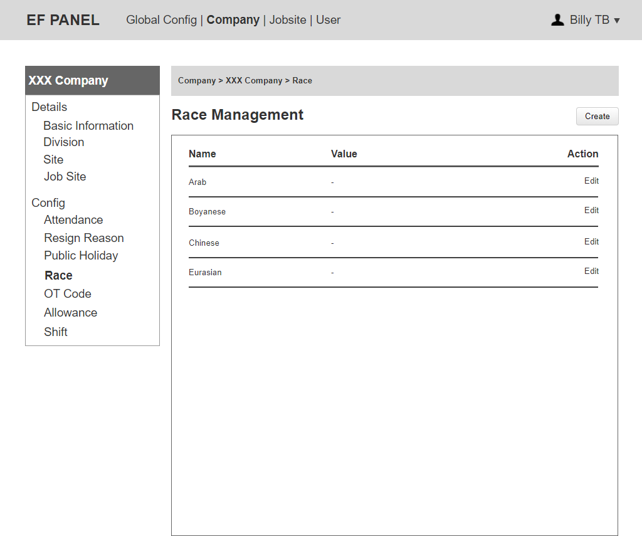

Figure 21: Race List

Notes:

* EF Admin and Company Admin can click on “Create” to add a new race.
* EF Admin and Company Admin can click on “Edit” to update name and value for a race.

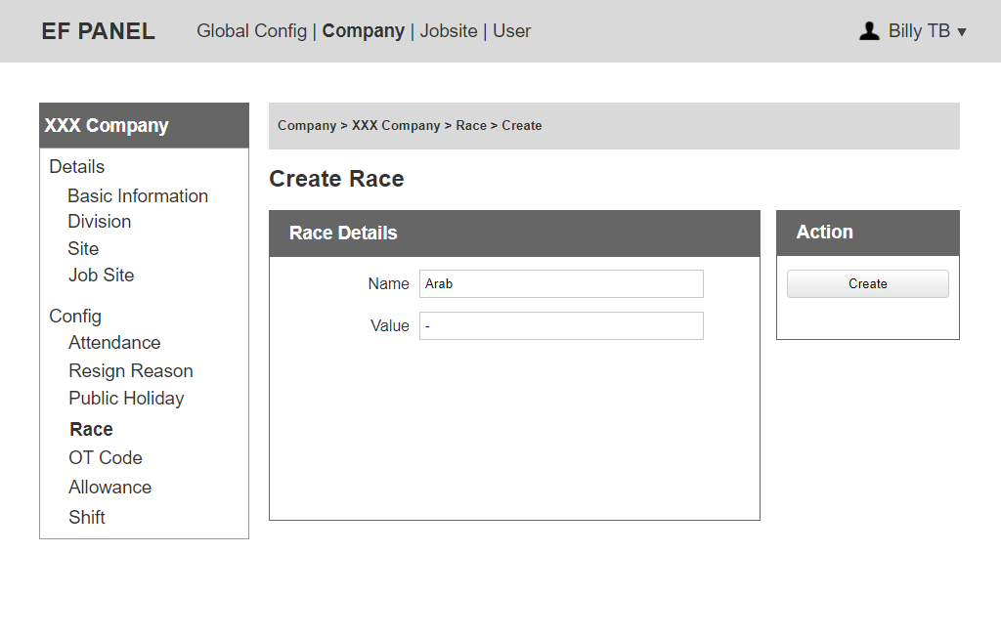

Figure 22: Create Race

### 3.2.5 OT Code

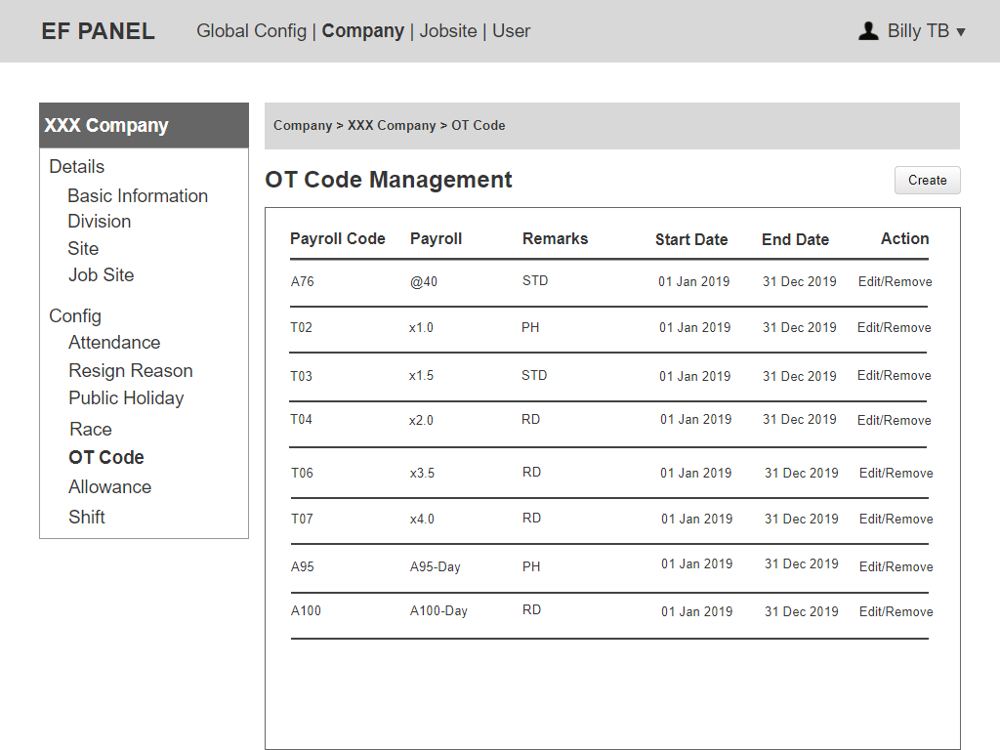

Figure 23: Company OT Code List

Notes:

* This is tied to default working hours. This value can be set differently for each job site.
  + Eg: Default working hours = 7.5, OT = 10 hours.

If Roster = RD

RD (A100) = 2 Days + STD = 10 – 7.5 = 2.5 hours.

If Roster = PH

PH (A95) = 1 Day + STD = 10 – 7.5 = 2.5 hours.

* Company Admin can click on “Edit” to update all information of a OT Code.
* After creation, an OT Code can only be removed if it has not been used (no children).

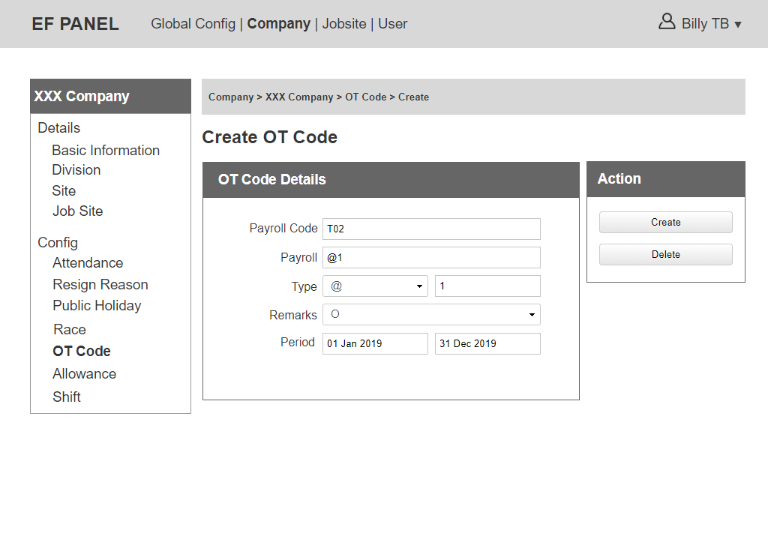

Figure 24: Create Company OT Code

Notes:

* Assign the different types of OT to each employee.
* Type includes: @, X, Day. Value corresponding: fix amount, multiple, day.
* Type = day: when show on OT report, show Payroll code + Payroll ‘type + rate’.
* Remarks dropdown includes: O, RD, STD, PH.
* Type = @, X, when show on OT report, show payroll ‘type + rate’.
  + e.g. Payroll code ‘A95’, type ‘day’, rate ‘1’ (or ‘2.5’) —> show A95 - Day 1 (or 2.5).
  + e.g. Payroll code ‘T35’, type ‘@‘, rate 2 —> show @2.

### 3.2.6 Allowance

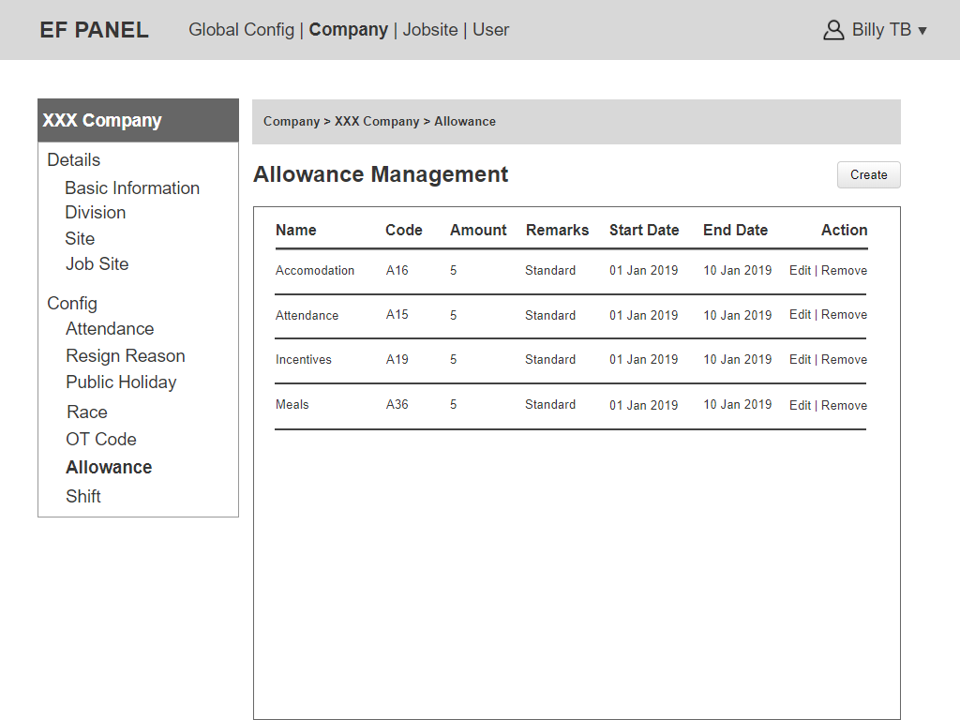

Figure 25: Company Allowance List

Notes:

* Company Admin can click on “Edit” to update all information of an allowance.
* After creation, an allowance can only be removed if it has not been used at Employee details (each employee has their own allowance code).

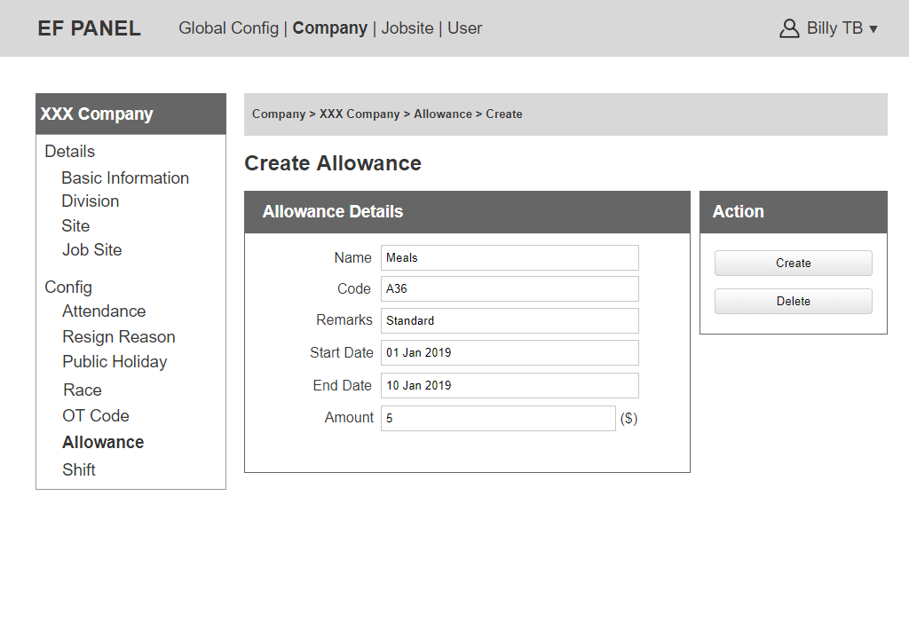

Figure 26: Create Company Allowance

### 3.2.7 Shift

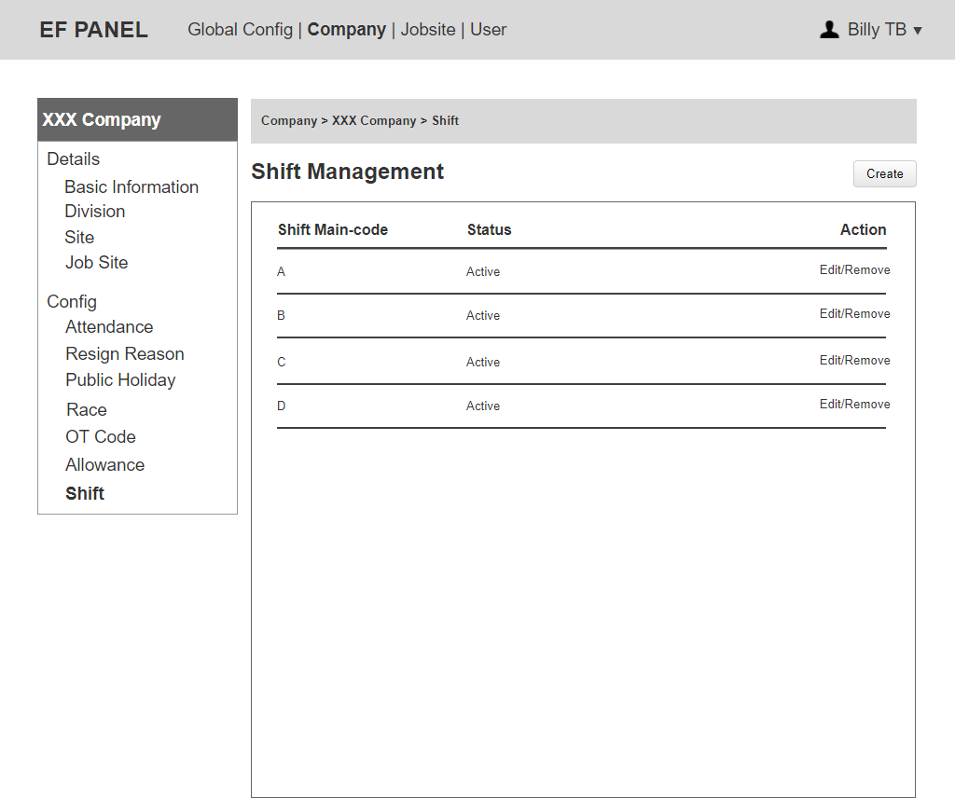

Figure 27: Shift List

Notes:

* Company Admin can click on “Edit” to update Shift main-code and the status.
* Able to remove if there is no children (no using in Job Site Shift).

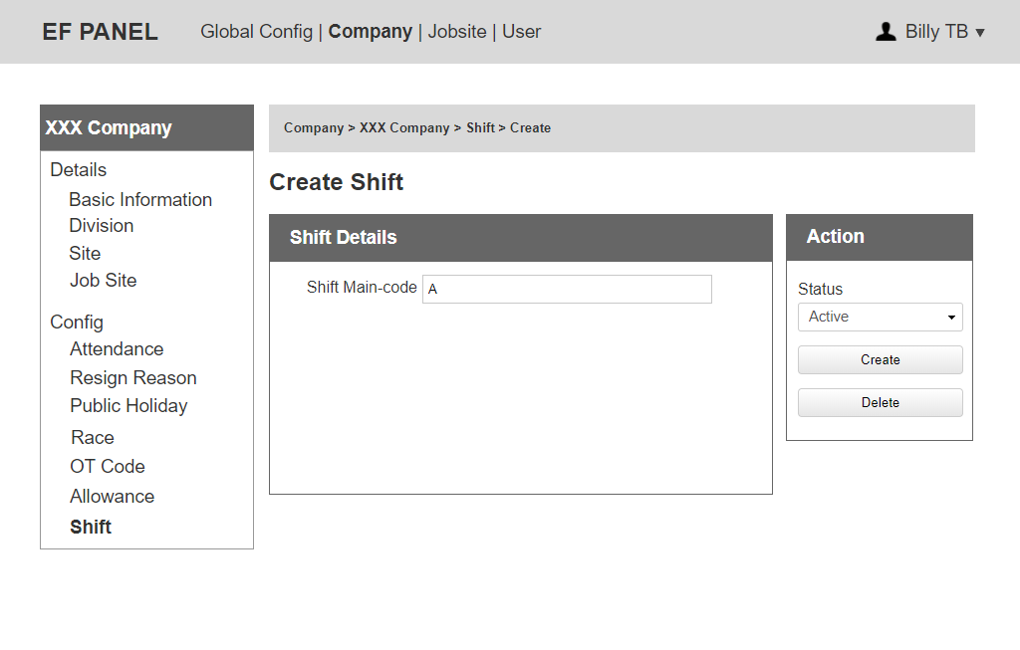

Figure 28: Create Company Shift

## Job Site

Note:

* EF Admin, Company Admin and Job Site Admin can edit information for Job Site Config.

### 4.1 Job Site List

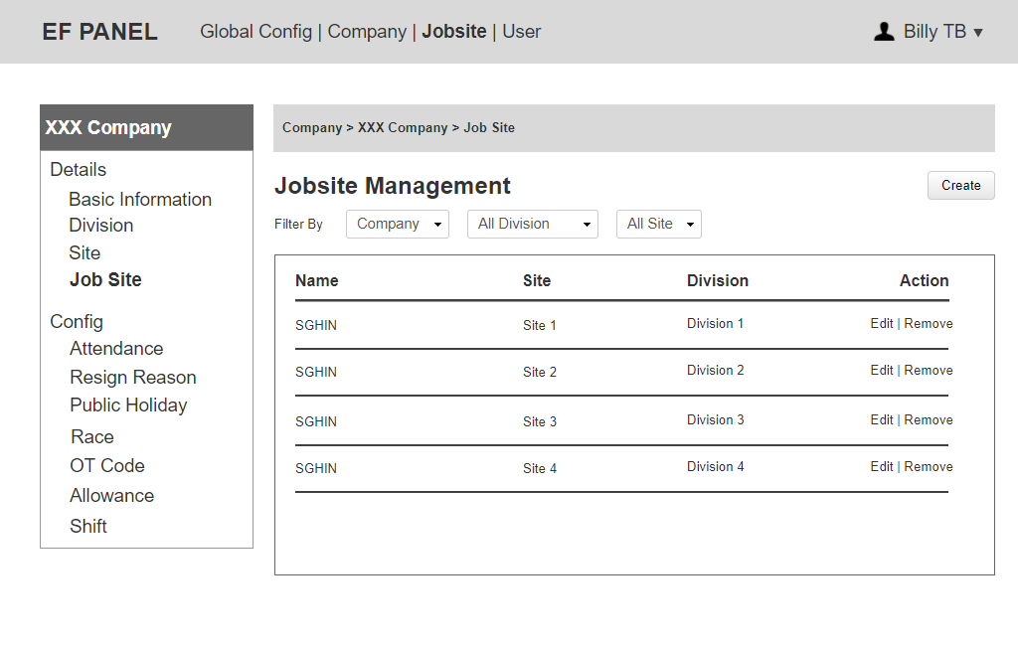

Figure 29: Job Site List

Notes:

* Only EF Admin can see Company dropdown on the filter.
* Can filter by Company, Division, Site.
* EF Admin and Company Admin can remove a Job Site if there is no transaction.
* Company Admin can only see its own job site.

### 4.1.1 Job Site Basic Information

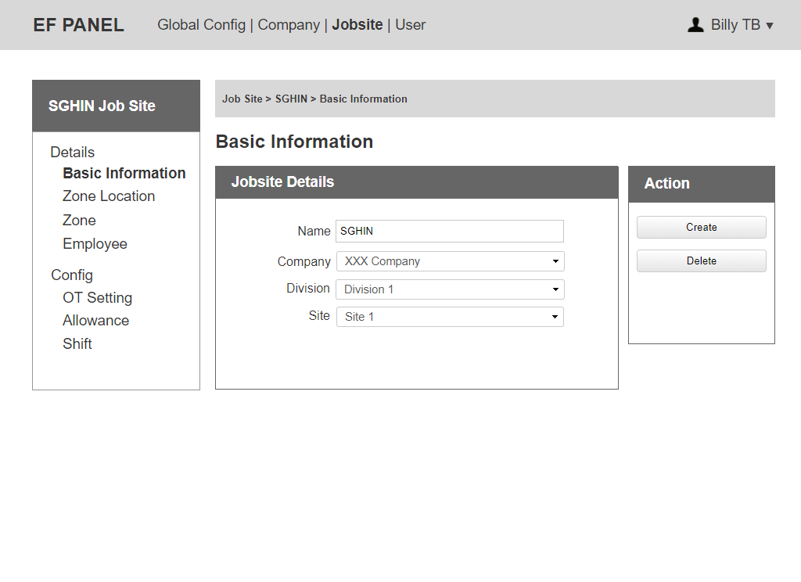

Figure 30: Job Site Details

Notes:

* Only EF Admin can edit Company dropdown, Company Admin cannot.

### 4.1.2 Job Site – Zone Location

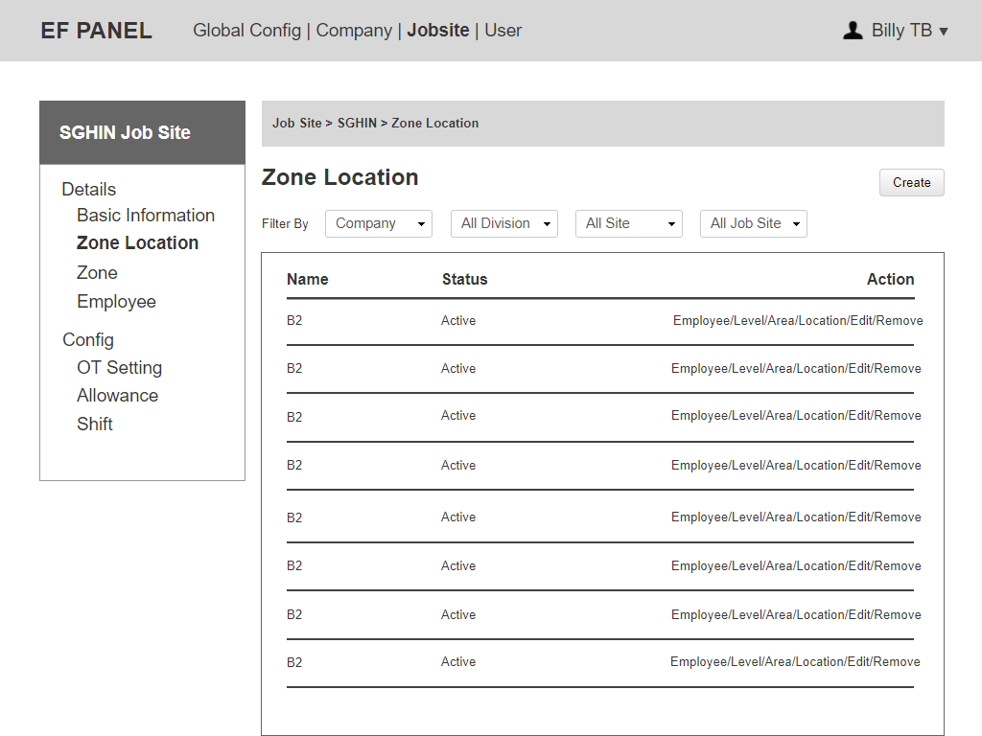

Figure 31: Job Site – Zone Location

Notes:

* Able to Create, Edit, Remove (if no employee belongs to it).
* Click on "Employee" to view Employee list belongs.
* Click on “Level/Area/Location” to view Level/Area/Location list.
* Able to filter by Company (only EF admin), Site, Department, Jobsite.

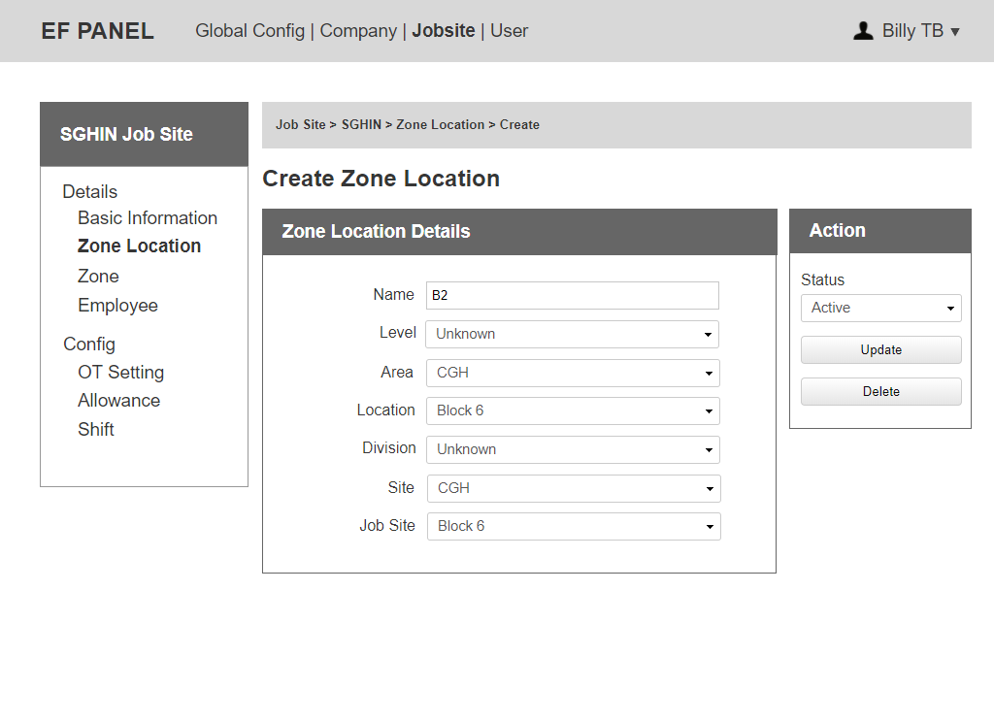

Figure 32: Job Site – Create Zone Location

Notes:

* Can Edit: Name, Level (dropdown from Level list), Area (dropdown from Area list), Location (dropdown from location list).
* Able to change Site/Department/Job Site belongs.
* Able to change the status.

### 4.1.2.1 Job Site – Level

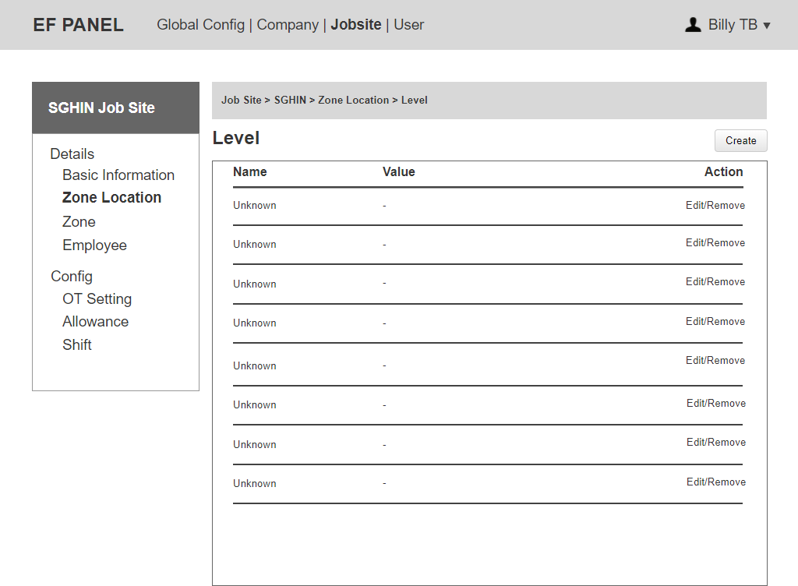

Figure 33: Job Site – Level

Notes:

* Can click on “Edit” to update all information of a Level.
* Able to remove if a level has not been used by any Company.

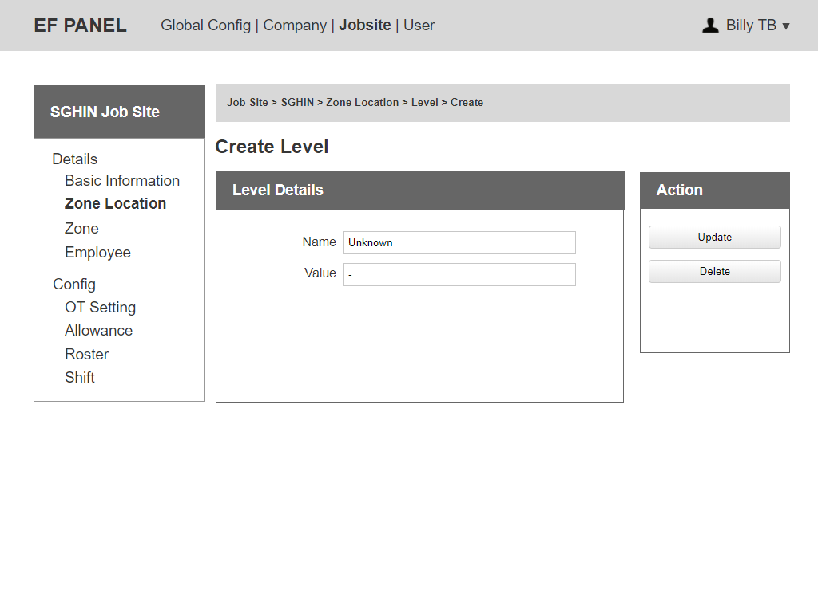

Figure 34: Job Site – Create Level

### 4.1.2.2 Job Site – Area

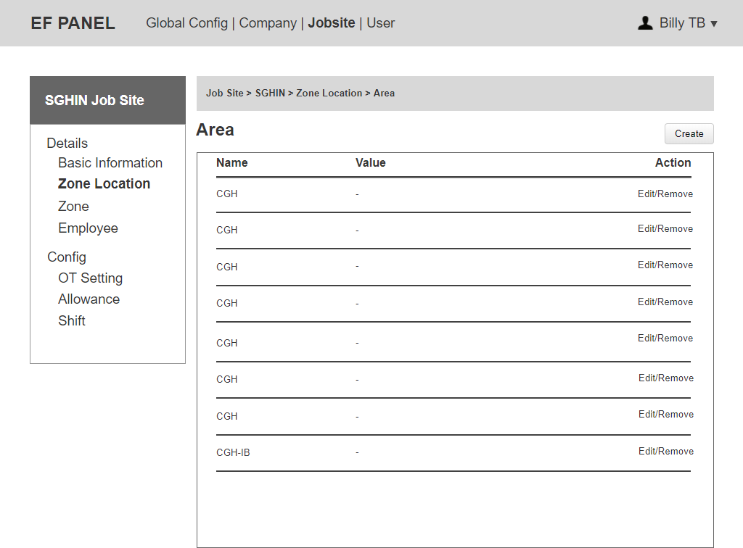

Figure 35: Job Site – Area List

Notes:

* Can click on “Edit” to update all information of an Area.
* Able to remove if an area has not been used by any Company.

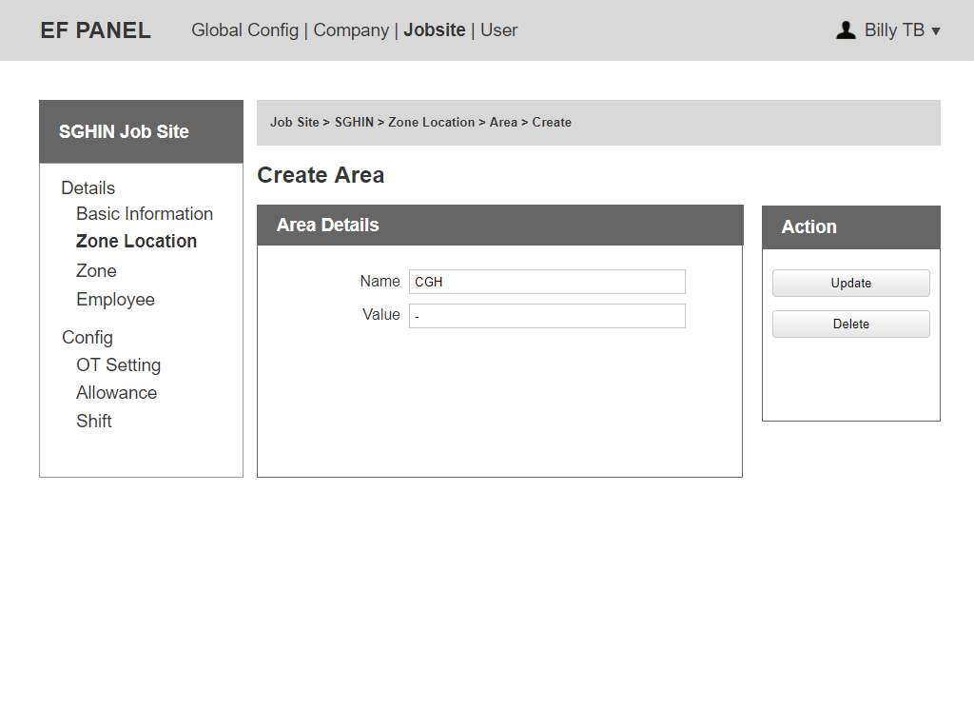

Figure 36: Job Site – Create Area

### 4.1.2.3 Job Site – Location

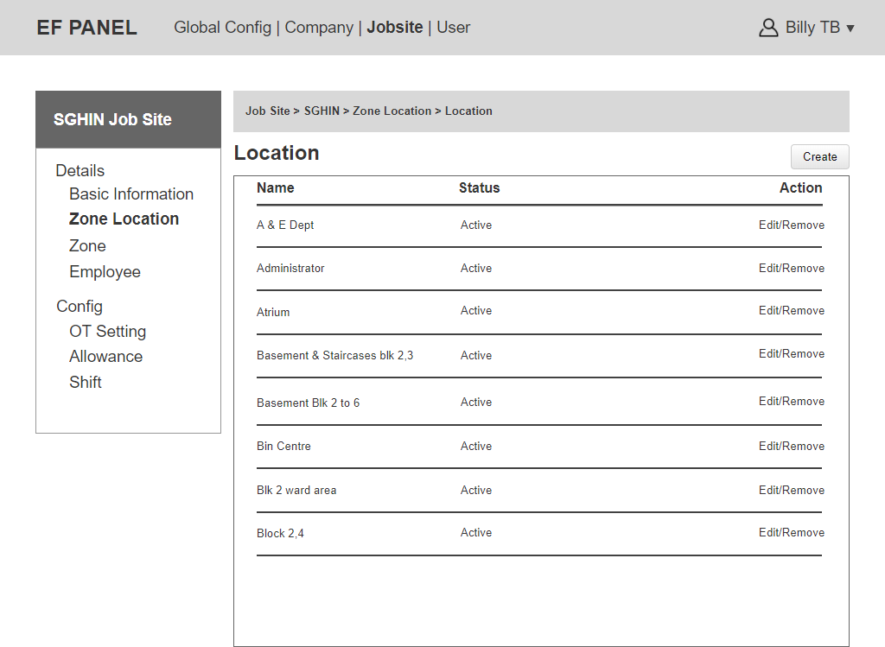

Figure 37: Job Site Location List

Notes:

* Can click on “Edit” to update all information of a Location.
* Able to remove if a location has not been used by any Company.

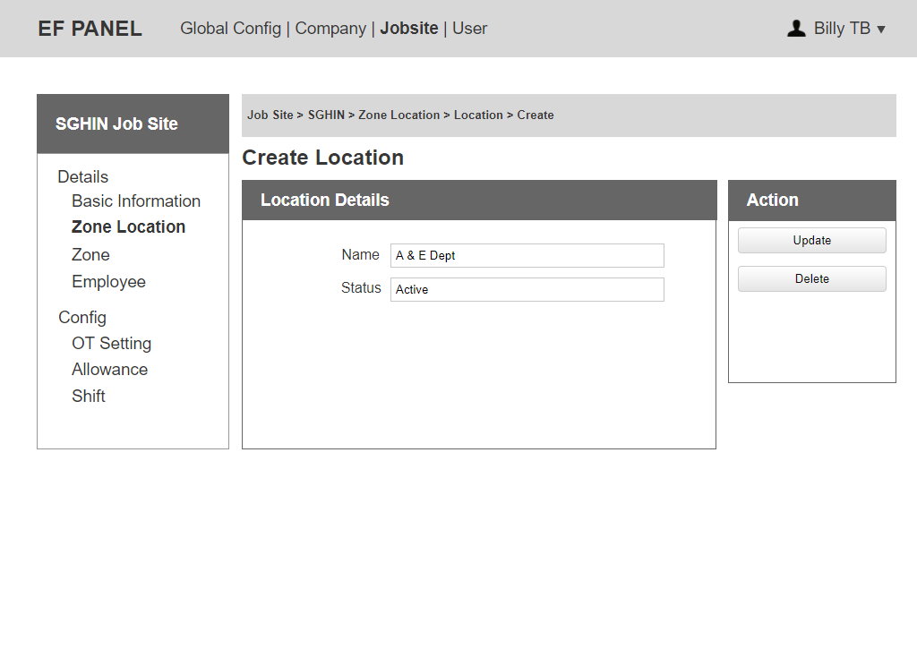

Figure 38: Job Site – Create Location

### 4.1.2.4 Job Site – Zone

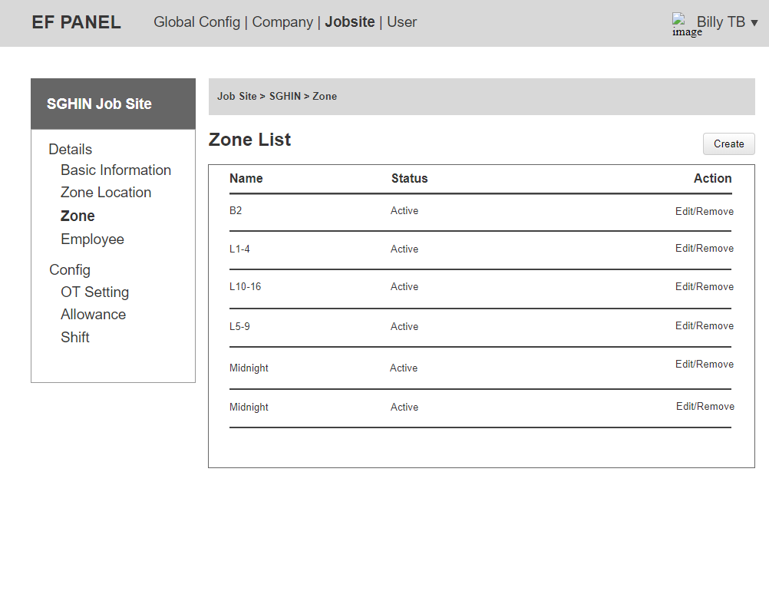

Figure 39: Job Site – Zone List

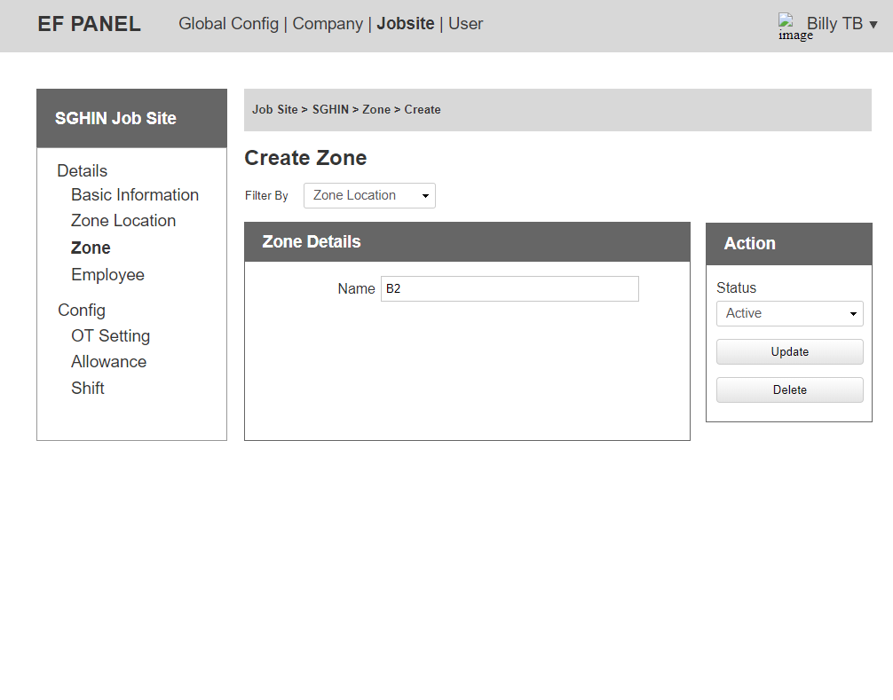

Figure 40: Job Site – Zone Details

### 4.1.2 Job Site Employee

It will be shown in point 6 on the below page.

### Job Site Config

### 4.2.1 Job Site OT Setting

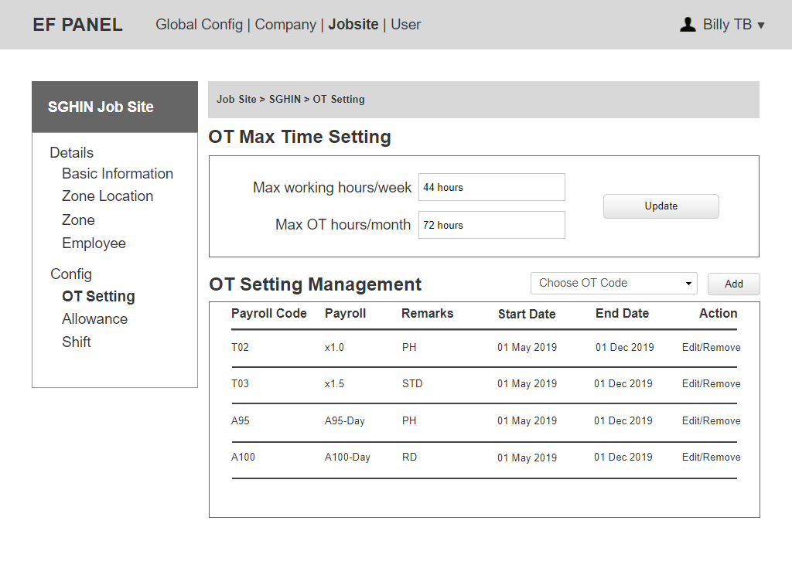

Figure 41: Job Site OT Setting

Notes:

* OT Max Time Setting will be used for OT with Standard + Off day. Is this setting for display purpose only or do you need us to actually stop record when OT hours of 'Standard + off day' is over 72 hours/week?
* Can set max working hours per week and max OT hours per month.
* The system will list all OT code in Company Config to dropdown "Choose OT Code”.
* Can click on “Edit” to update for type, remarks, period.
* After creation, an OT Code can only be removed if it has not been used (no children).
* OT Max Time Setting is used to alert admin to send Email notification for each Employee if they reach 72 hours limit.

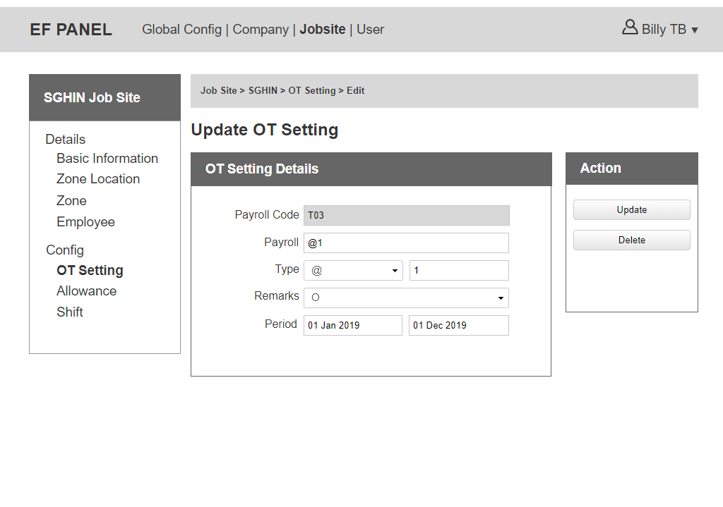

Figure 42: Company OT Rate Setting Update

Notes:

* At Job Site Config, Admin cannot allow to create a new OT code. Admin only allow to choose the OT code from Company Config then update value, remarks and period.
* Remarks includes: PH, STD, O, RD.
* Type = @, X, when show on OT report, show payroll ‘type + rate’.
  + e.g. Payroll code ‘A95’, type ‘day’, rate ‘1’ (or ‘2.5’) —> show A95 - Day 1 (or 2.5).
  + e.g. Payroll code ‘T35’, type ‘@‘, rate 2 —> show @2.

### 4.2.2 Job Site Allowance

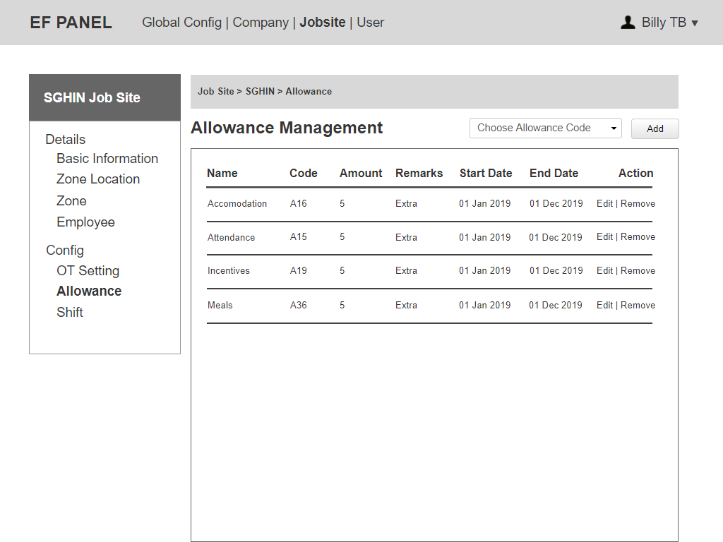

Figure 43: Job Site Allowance List

Notes:

* The system will list all active allowance code in Company Config to dropdown "Choose Allowance Code”.
* Can click on “Edit” to update value for an allowance.
* After creation, an allowance can only be removed if it has not been used (no children).

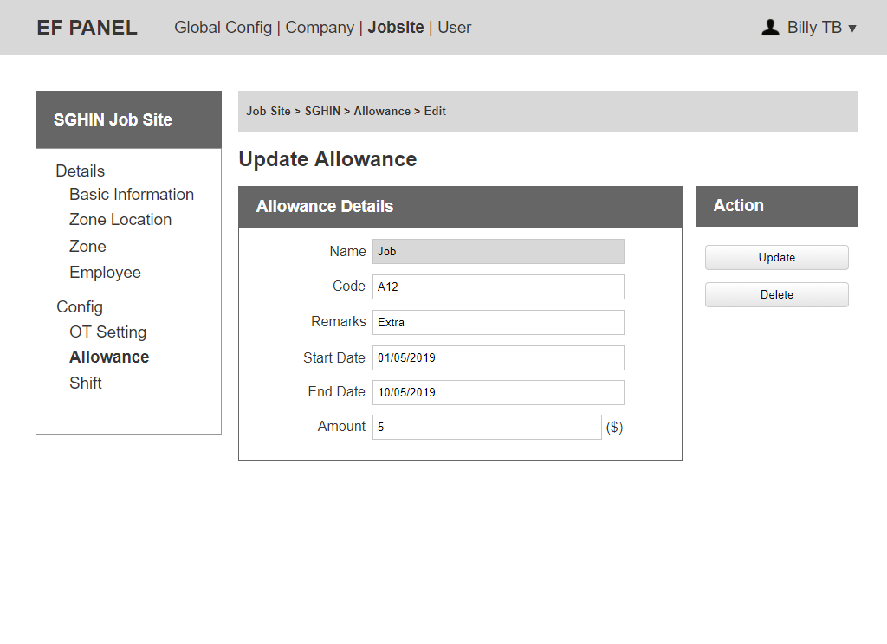

Figure 44: Allowance Update

Notes:

* Only can update value for an allowance.

### 4.2.4 Job Site Shift

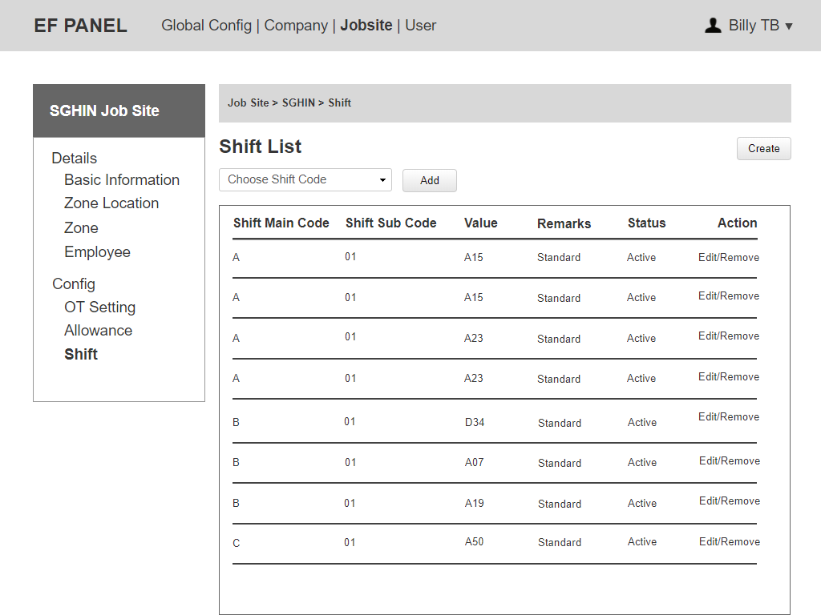

Figure 45: Job Site – Shift List

Notes:

* Can choose Shift Code from Company Shift to update then use in Job Site Shift.
* Can create a new shift code.
* Able to update all information of a Shift.
* Cannot remove if a shift has been used.

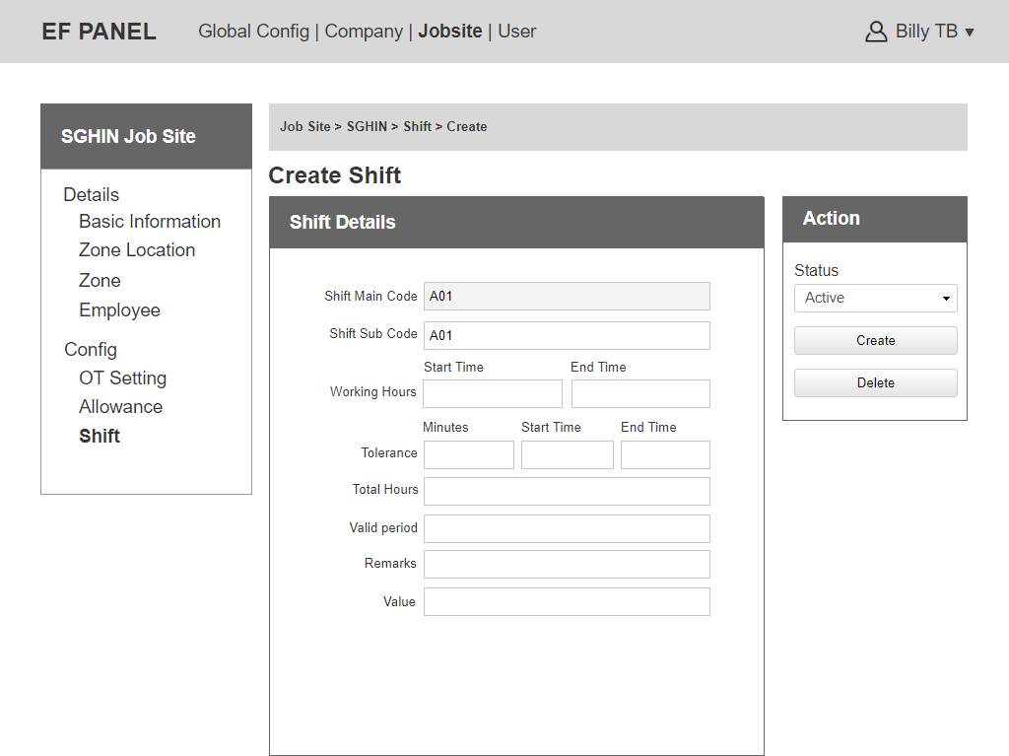

Figure 46: Job Site – Create Shift

## Employee

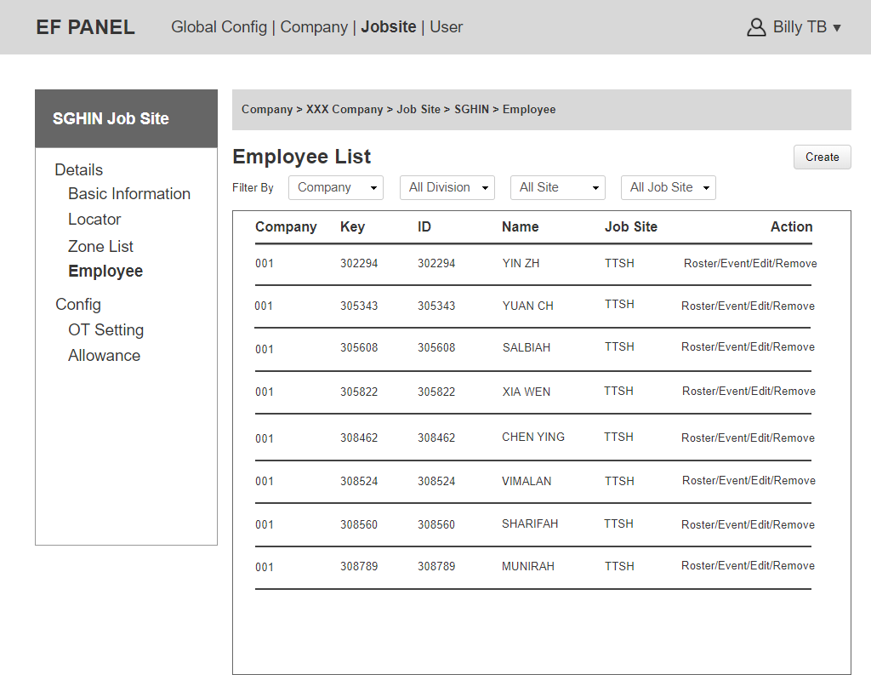

Figure 47: Employee List

Notes:

* Can click on “Create” to add a new employee.
* Can click on “Edit” to update all information of an employee.
* Can click on “Remove” to delete an employee.
* Only EF admin is allowed to edit the “company dropdown”.
* Can click on “Roster” to see Roster List belong to this employee.
* Can click on “Event” to choose and update Event Type for this employee.
* Any changes of Employee must be logged.

### 5.1 Employee Details

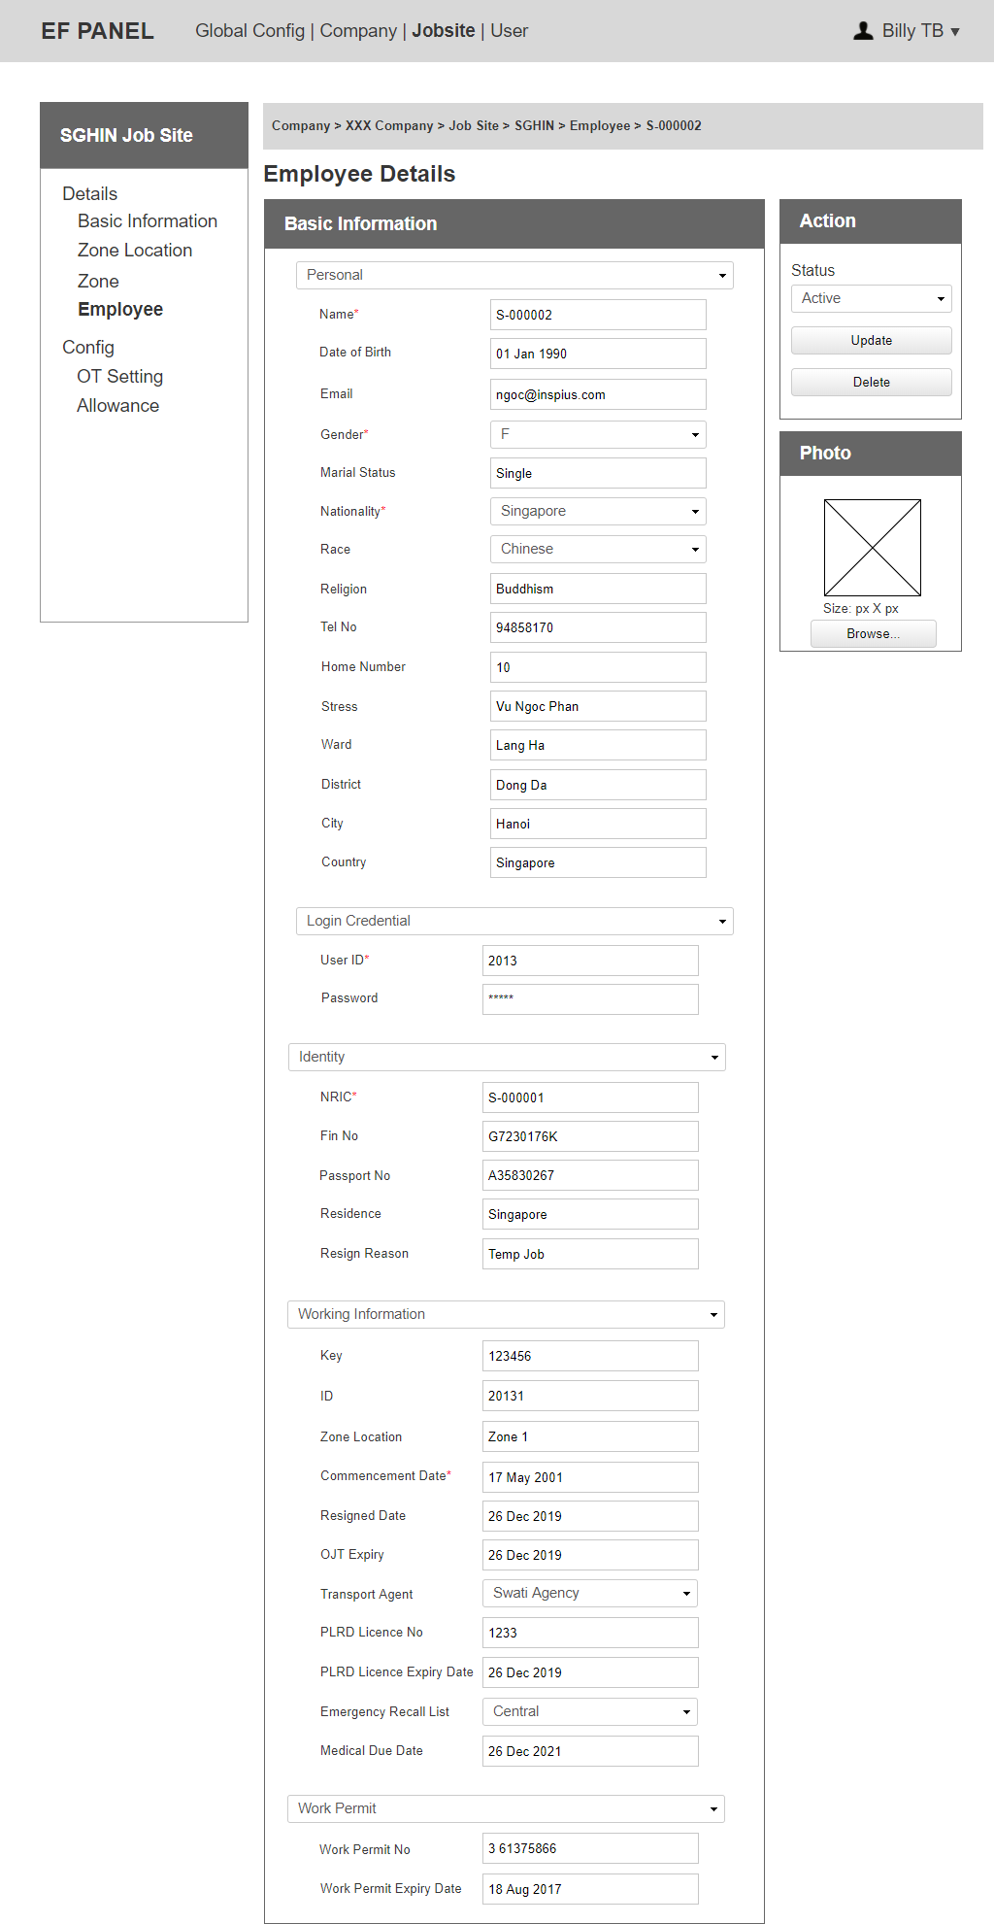

Figure 48: Employee Details

Notes:

* Allowance can be set at Employee Event.

### 5.2 Employee Event – Promotion

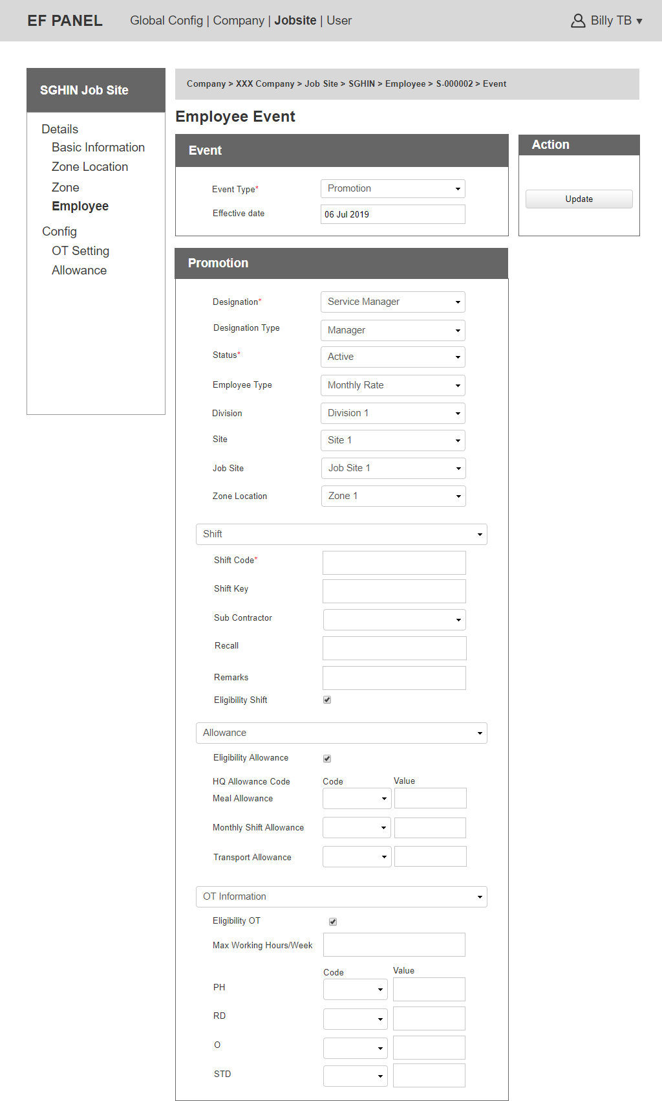

Figure 49: Employee Event - Promotion

Notes:

* Able to change: Job title or Designation, Allowance, OT, Shift, Zone.
* Able to change Jobsite + Department + Site if needed.
* Shift Code would be retrieved from Job Site Shift Code.
* OT Code would be retrieved from Job Site OT Code.
* HQ Allowance Code would be retrieved from Job Site Allowance Code.
* At the first time, designation can be created. The second time, designation can only be edited.

### 5.3 Employee Event – Termination/Resign

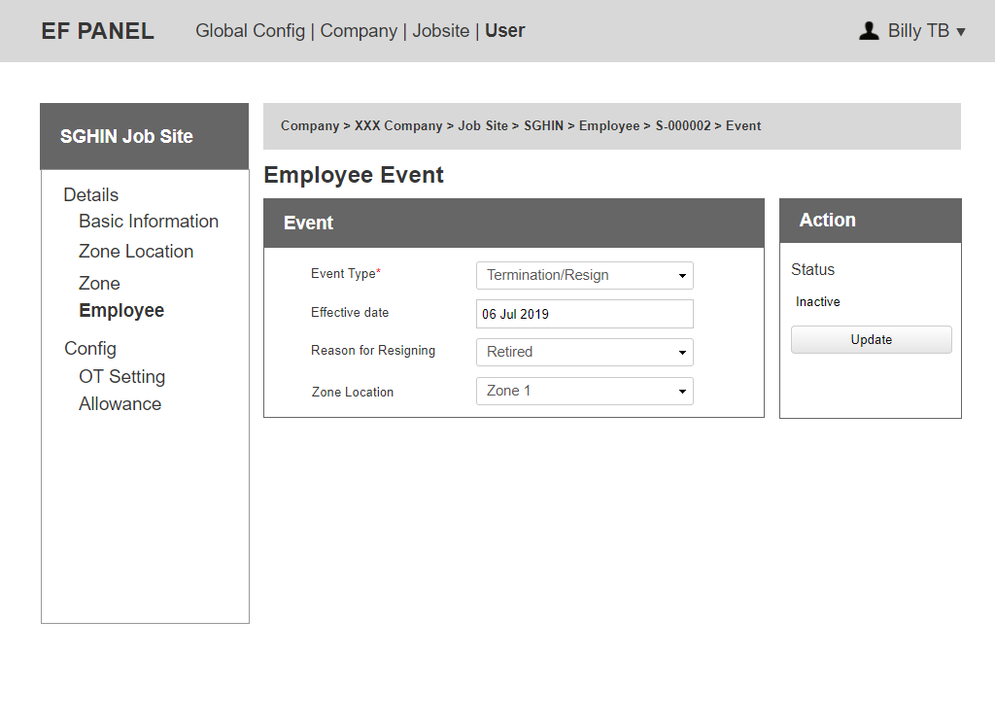

Figure 50: Employee Event – Termination/Resign

Notes:

* The status of Employee Termination/Resign is automatically changed to Inactive.
* Reason for Resigning would be automatically retrieved from Resign Reason of Job Site.

### 5.4 Employee Rejoin

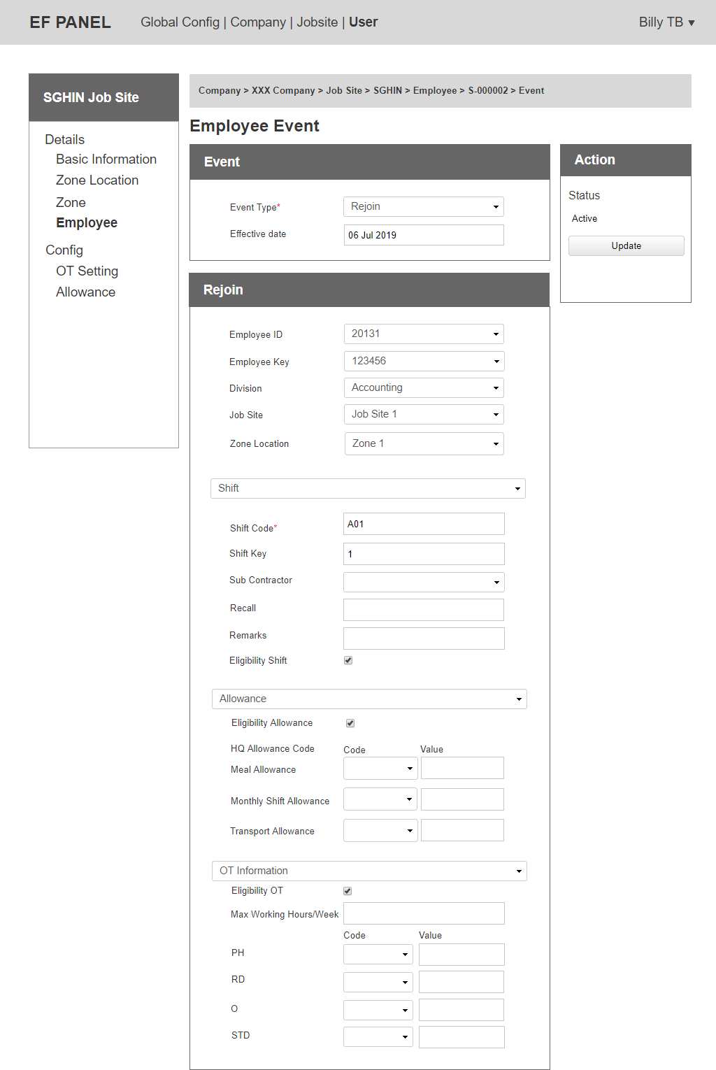

Figure 51: Employee Event Rejoin

Notes:

* The status of Employee Rejoin is automatically changed to Active.
* The Employee will be issuing a new Employee ID, Employee Key. We will use the same Employee ID, Employee Key (the system generated number) as unique identification. However can update Employee ID, Employee Key (based on company).
* Shift Code would be retrieved from Job Site Shift Code.
* OT Code would be retrieved from Job Site OT Code.
* HQ Allowance Code would be retrieved from Job Site Allowance Code.

### 5.5 Employee Contract

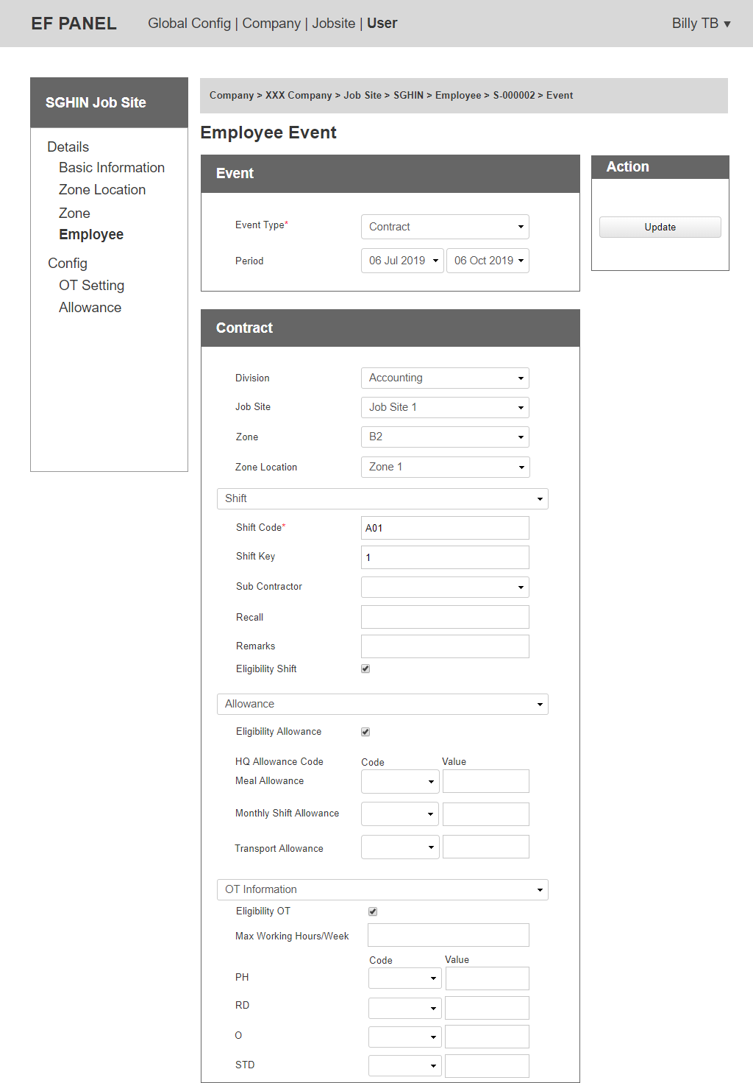

Figure 52: Employee Event ContractNotes:

* Can change: department, jobsite, zone.
* When an employee is in stop contract (after end date), the status will be automatically change to “Inactive”.
* Shift Code would be retrieved from Job Site Shift Code.
* OT Code would be retrieved from Job Site OT Code.
* HQ Allowance Code would be retrieved from Job Site Allowance Code.

### 5.6 Employee Transfer

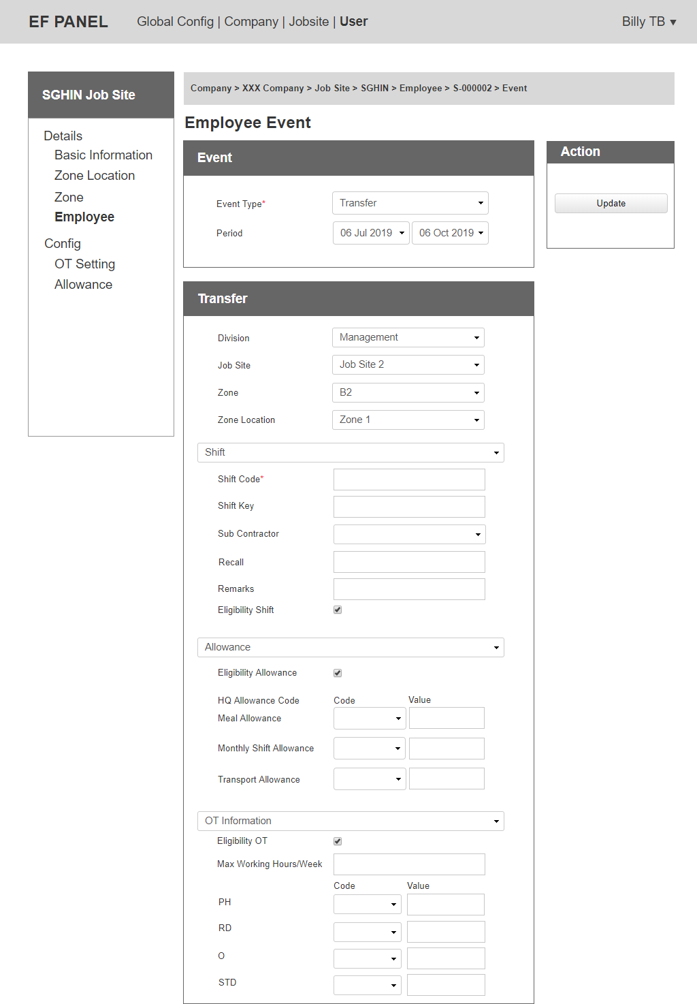

Figure 53: Employee Event Transfer

Notes:

* Can change: department, jobsite, zone.
* After end date, an employee can automatically transfer back to the latest zone/jobsite/department).
* Shift Code would be retrieved from Job Site Shift Code.
* OT Code would be retrieved from Job Site OT Code.
* HQ Allowance Code would be retrieved from Job Site Allowance Code.

### 5.7 Employee Roster

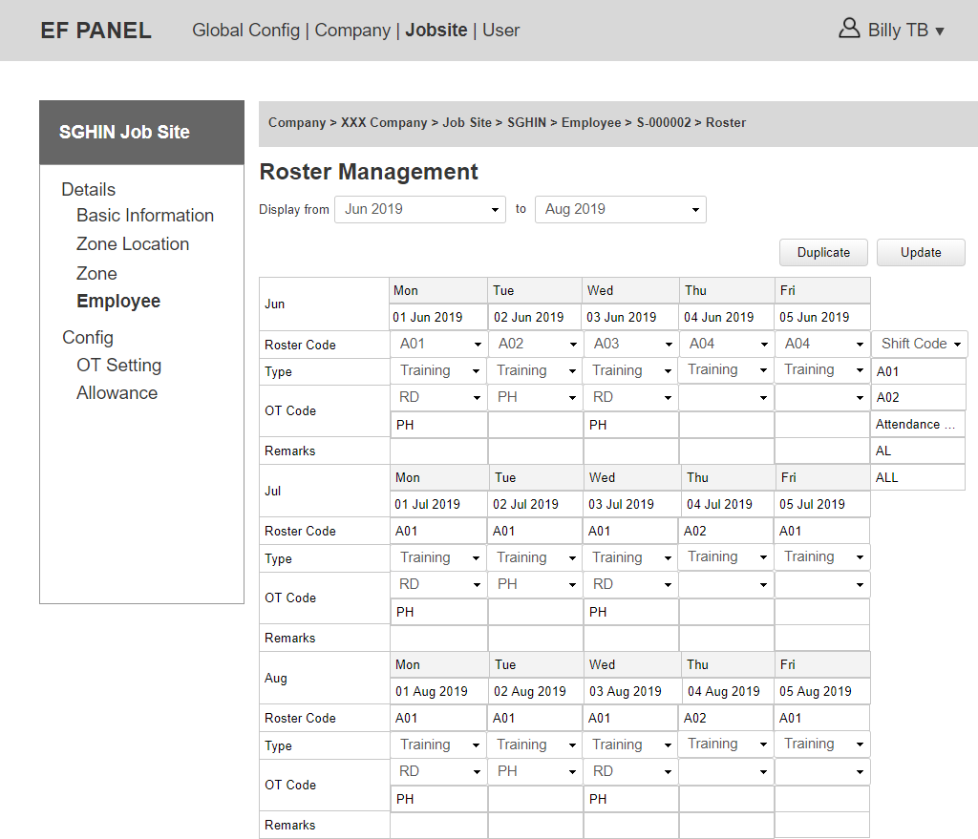

Figure 54: Employee Roster

Notes:

* Shift Code will be automatically retrieved from Shift Job Site then can be edited.
* Able to click on Shift code dropdown to show Attendance code to update for it.
* OT Code will be automatically retrieved from OT Code of this Employee Event then can be edited.
* Choose to send roster to employee via email.
* Notify if set roster on leave-date of an employee.
* Roster planning is on month basis, default show from 3 months ago.
* When a roster is updated, any changes about Job Site can not affect to the roster before effective date.
* If blank, it is counted as STD (OT code).
* Admin can click on “Update” to update details of a roster code.
* Admin can click on “Duplicate” to duplicate this month plan to next week/month/year plan, from date to date.
* Roster Code is dropdown of Shift Code and Attendance Code.

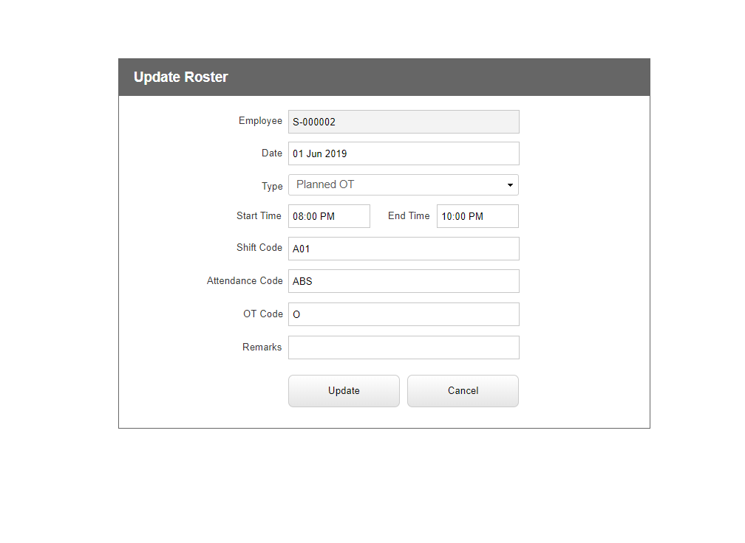

Figure 55: Update Roster

Notes:

* Able to update all information of a roster code except Employee Name.
* Type includes: Planned OT, Vaccination, Training.

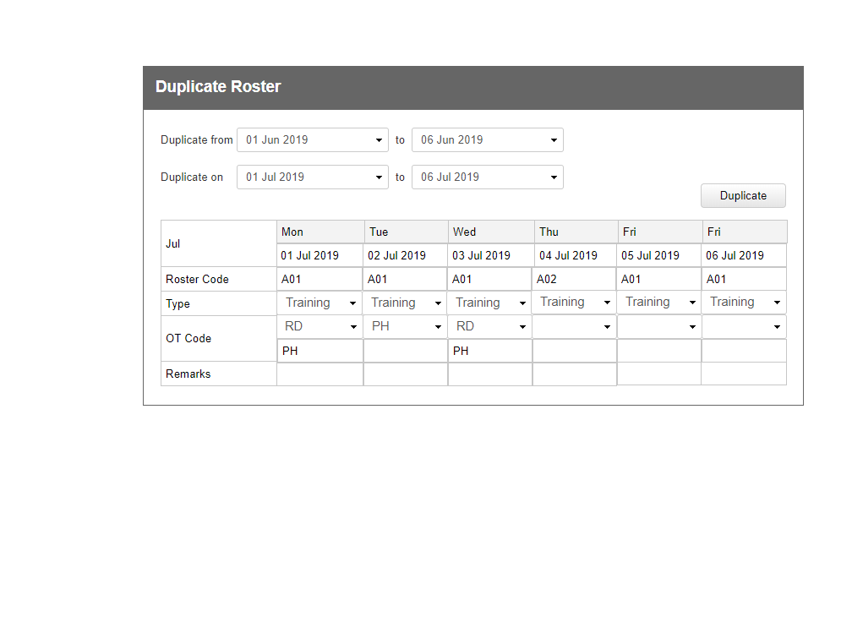

Figure 56: Duplicate Roster

Notes:

* Can duplicate roster code from date to date if it is from the past to the future.